Name:_________
Year 5
Week 13
WB 29.06.20
SILVER AND GOLD

READING DAY 1 VOCABULARY

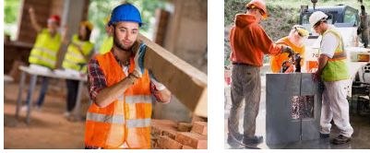
Labourer – someone who does a physical job

Remote – a place that is far away from anything else

Suffer – when you experience sadness
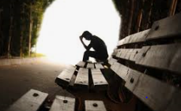

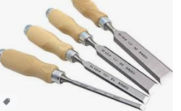
Fate – events that happens that you cannot control
Chisel - a tool used to shape wood or other surfaces

Carved – when tools are used to shape something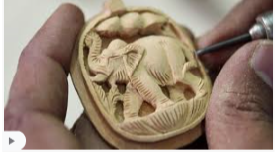

Access – when you can get through to somewhere or use something easily

Documentary – a video to show what happened – these are always true

Mission – an important task
Questions
Silver
- Which word is used to describe something that is not near anything else?
- What can people watch to get information from an event that happened?
- What kind of people might go on missions?
- List 3 things you have access to in your life
- What is the object called that shapes surfaces?

Gold
- Which word is a synonym for ‘task’?
- Which word can be a synonym for ‘entry?
- Which word is a synonym for ‘destiny’?
- Which word is a synonym for ‘isolated’?

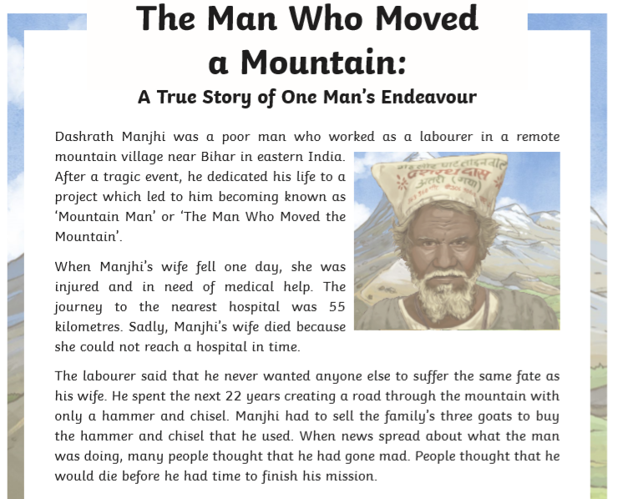
READING DAY 2 READ ALOUD, THINK ALOUD – text marking

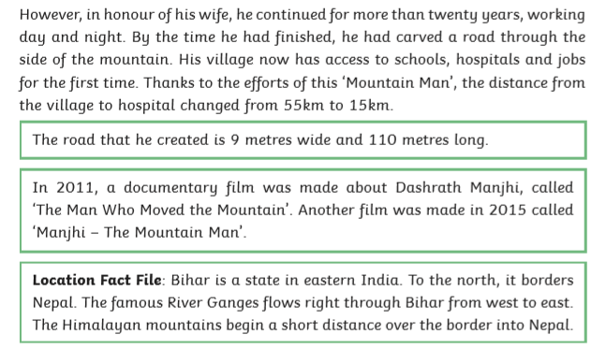
1) Read this text line by line and text mark. If there are any words that you are still unsure of underline them, read before and after and try to work out what it means in context.
2) When finished read it again to make sure you understand the text.
Challenges: - Ask an adult or sibling to time you reading this text. - What is this text about/what is this text going to be about? - Find and copy 3 proper nouns. - Find and copy 3 verbs

READING DAY 3 RETRIEVAL
Silver
1. Where did Dashrath work?
2. How far was the closest hospital?
3. What did Dashrath have to sell to fund his chisel and hammer?
4. Name the two films made about Dashrath

Gold
1. Which country is next to Bihar?
2. What is the water of body that runs through Bihar?
3. Once Dashrath had finished carving the mountain, what was the new distance from the village to the hospital?

READING DAY 4 INFERENCE

SILVER and GOLD
- Who did Dashrath need to help?

- Since the mission took 22 years, use 2 adjectives to describe Dashrath. (Not the way he looks)

- Why do you think he is known as ‘The Man Who Moved a Mountain’

- Why did Dashrath have to sell his goats?

- Why you think people thought Dashrath would die before he finished his mission?

- How do you think the village people felt once Dashrath had finished?

Science
The heart
The heart is an organ and it is the heart along with veins and arteries that make up the circulatory system.
Do you know the answers to these questions? Tell somebody nearby, check the answers.
Which gas is carried in the blood?
What do muscles need to work?
What is the hearts job?
Where does blood go?
Why does blood get pumped around the body?

Click on the links below to find out more
http://www.bbc.co.uk/education/clips/z9dg9j6 - The heart and how it works
http://www.bbc.co.uk/education/clips/zj7qxnb - Hearts and how to keep them healthy
Heart Rate
Heart rate is a measure of the number of times the heart beats in a minute. Use two fingers to feel your heart rate (either on your wrist or neck) and count how many times it beats in a minute. Fill out the chart below.

Heart Rate
Activity | Heart beat(s) per minute
Resting
10 star jumps
Jogging on the spot for 30 seconds
Sprinting on the spot for 30 seconds

Answers
What gas is carried in the blood? – oxygen
What do muscles need to work? – oxygen
What is the hearts job? – to pump blood around the body
Where does blood go? – around the body
Why does blood get pumped around the body? – to drop off oxygen and picking up carbon dioxide

Relaxtion Activities 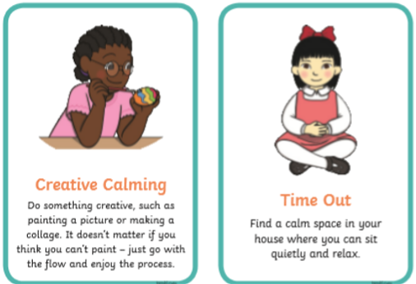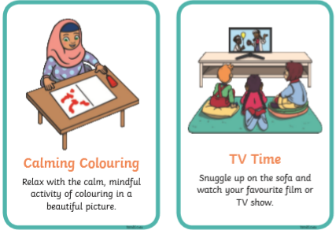
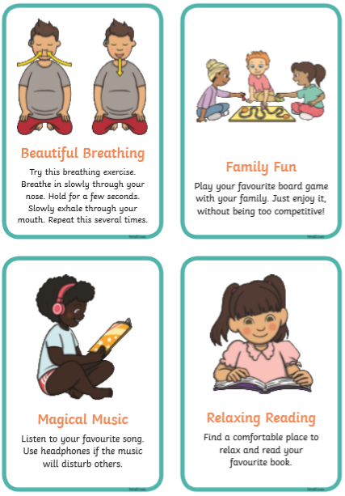

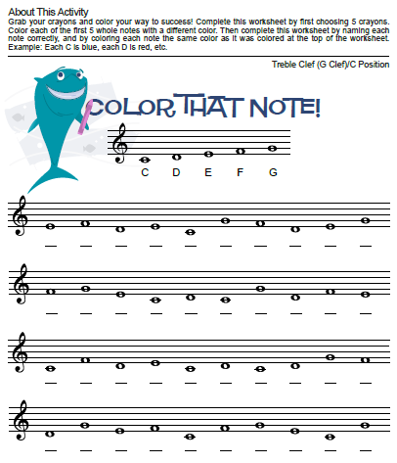
MUSIC

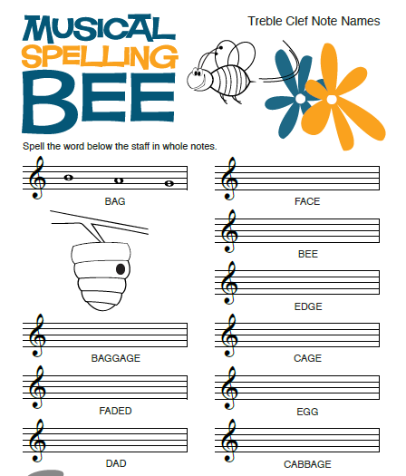

Art
Artist: Keith Haring
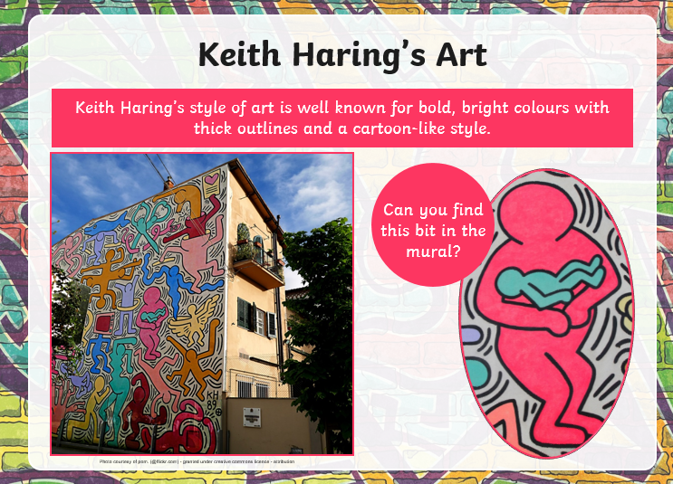

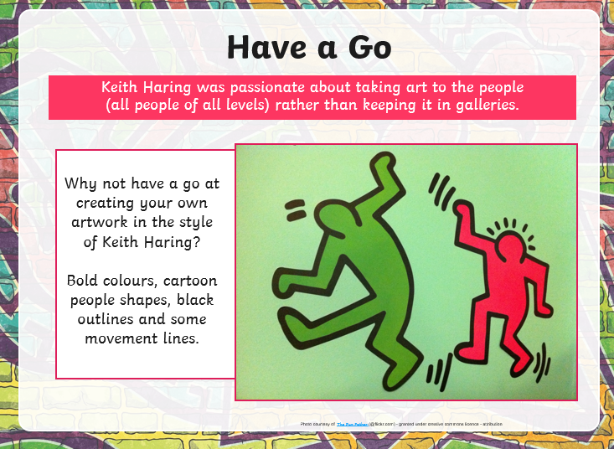

Mindfulness
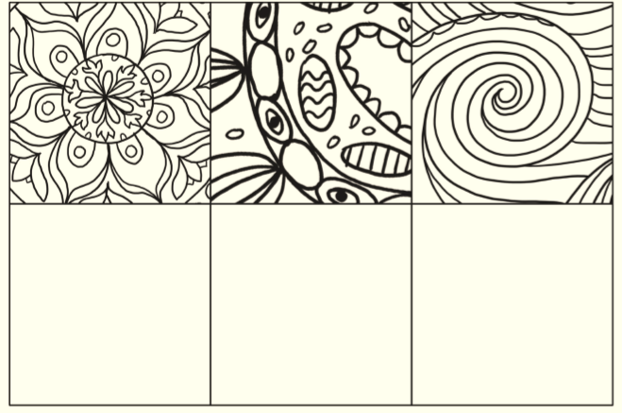
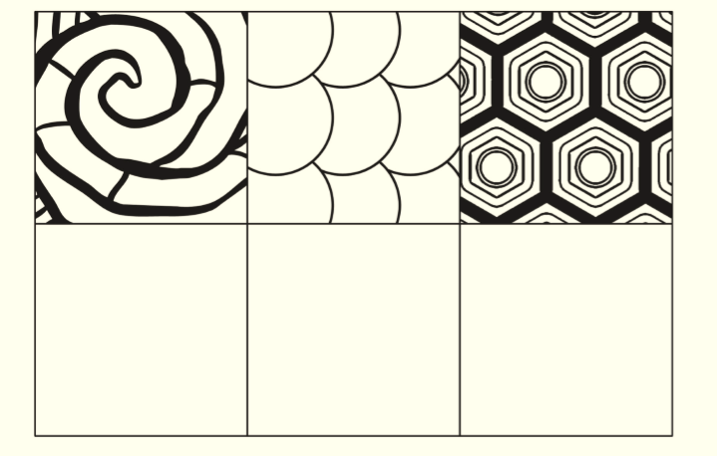
Take time to switch off your mind and focus on a simple creative task. Copy the patterns below or make up your own.

Literacy
Day 1: Spelling, Punctuation and Grammar
These are non-negotiable spellings to learn in year 5/6. Each day practise all ten spellings (using the strategies in the table underneath).
- dictionary
- programme
- muscle
- identify
- existence
- equipped
- definite
- average
- temperature
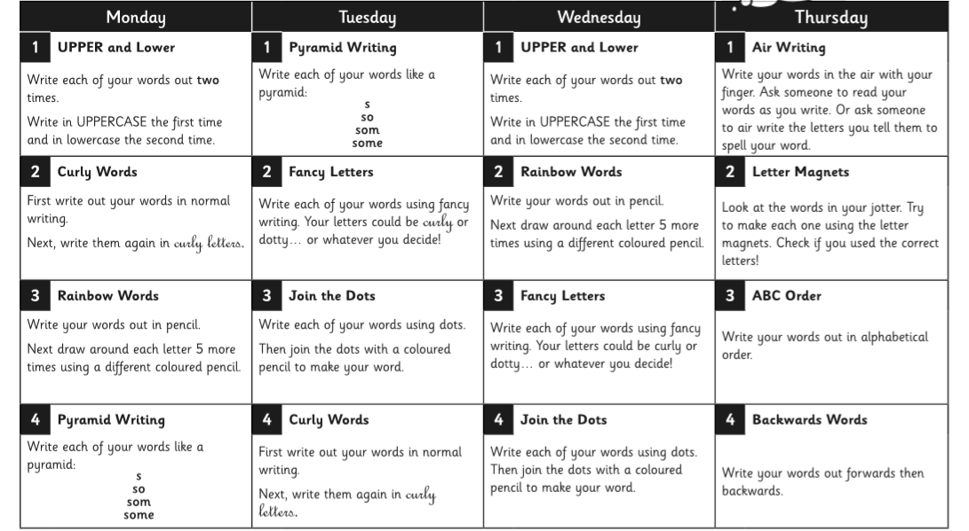
- community

Literacy
Day 2: Spelling, Punctuation and Grammar
Activity
- Look at Day 1 and complete the spelling activities for Tuesday
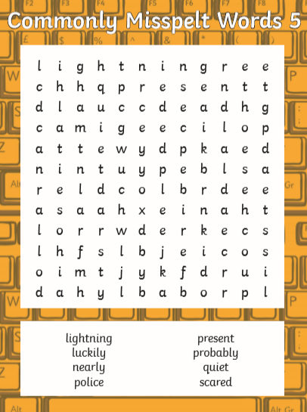
- Complete the word search to find words underneath
Literacy
Day 3: Spelling, Punctuation and Grammar
Activity
- Look at Day 1 and complete the spelling activities for Wednesday
- Write a story using three of the spellings (e.g. temperature, average and community)
Remember the correct punctuation (capital letters, full stops, commas, brackets).
________________________________________________________________________________________________________________________________________________________________________________________________________________________________________________________________________________________________________________________________________________________________________________________________________________________________________________________________________________________________________________________________________________________________________________________________________________________________________________________________________________________________________________________________________________________________________________________________________________________________________________________________________________________________________________________________________________________________________________________________________________________________________________________________________________________________________________________________________________________________________________________________

Literacy
Day 4: Writing
Activity
- Look at Day 1 and complete the spelling activities for Thursday
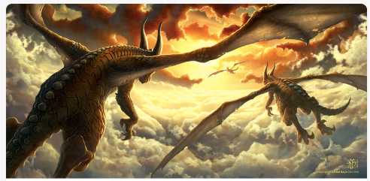
- Dragonworld

Read the Story Starter
This was their favourite time of day to fly.
As the glowing, crimson sun dipped down below the vast horizon, retreating to allow night to take its place, the dragons took flight.
The sky looked beautiful: wisps of pillow-like clouds seemed to part in front of them as they flexed their powerful wings. Like sails from ancient ships, the wings beat in the dying embers of the sun’s fire, embracing what little warmth remained. Thousands of tiny scales that covered the beasts’ bodies glistened like rubies in the dazzling light.
As they reached full speed, leaving the world far beneath them, they almost grinned as they thought about where they were going. There would be others like them there. It would be paradise…
Answer questions
Where are the dragons heading?
What is ‘paradise’? Why are they looking forward to it so much?
Where have the dragons come from? Where is their home?
If you had a pet baby dragon, how would you look after it?
Literacy
Day 5: Writing
Activity
- Look at Day 1 and test yourself on the spellings (using look, cover, write, check)
- Dragonworld
Reread the Story Starter
This was their favourite time of day to fly.
As the glowing, crimson sun dipped down below the vast horizon, retreating to allow night to take its place, the dragons took flight.
The sky looked beautiful: wisps of pillow-like clouds seemed to part in front of them as they flexed their powerful wings. Like sails from ancient ships, the wings beat in the dying embers of the sun’s fire, embracing what little warmth remained. Thousands of tiny scales that covered the beasts’ bodies glistened like rubies in the dazzling light.
As they reached full speed, leaving the world far beneath them, they almost grinned as they thought about where they were going. There would be others like them there. It would be paradise…
Writing Challenge
Imagine that you are the dragon and you have landed in your paradise. What can you see? How do you feel? What can you hear? ____________________________________________________________________________________________________________________________________________________________________________________________________________________________________________________
Drawing Challenge
Can you draw what you think a dragon’s home might look like? Think carefully about what dragons are fond of.

