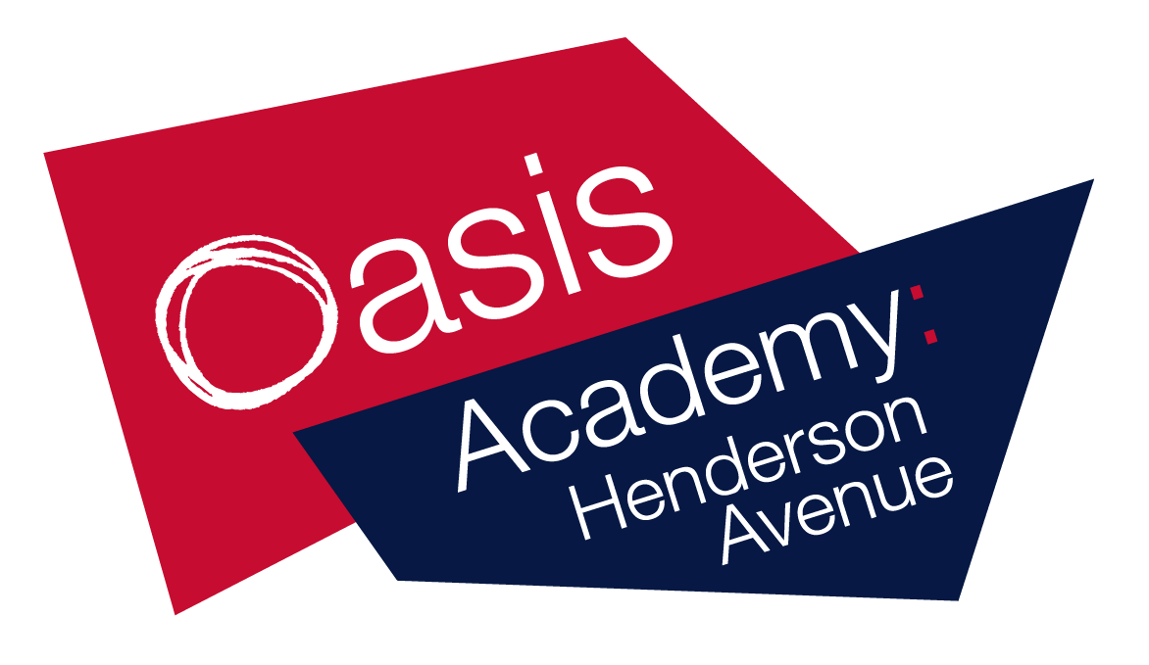

Name:_________
Year 5
Week 12
WB 22.06.20

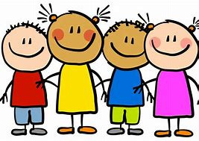
Dear children, parents and carers,

Although school is closed, we still want you to have access to high-quality
resources.

To help you and to provide online access to these resources, please take a look at the links below. They are all FREE!

Also please follow these your teacher on twitter for regular updates!
- @MarshallOAHA
- @GladmanMiss
- @MissWilliamsY5
Keep working hard and stay safe!
ukhosted14.renlearn.co.uk/6698989 - This is the website which children in years 3 to 6 use to quiz on books they have read. Children will now be able to access this from home, Monday to Friday.
https://ttrockstars.com/ - This is a website where children are able to practise their times tables.
Lovereading4kids.co.uk - An extensive library of books, including classics and brand new released, with reviews, plots and downloadable extracts. Sign up for free.
https://pages.sumdog.com/ This is a website where children can complete maths and spelling practise.
https://www.bbc.co.uk/bitesize/levels/zbr9wmn A website where children and parents can access all curriculum areas.
Twinkl.co.uk/offer A website where children and parents can access all curriculum areas. To access enter the code UKTWINKLHELPS
https://www.duolingo.com A website where children can learn a new language. At OAHA we teach French.
https://classroomsecrets.co.uk/ A website where children can access all curriculum areas.
https://shop.scholastic.co.uk/homelearning A pack of work for home learning.
https://whiterosemaths.com/ A website full of maths resources.
https://2simple.com/free-access/ A website full of cross-curricular activities and resources.
Pobble365.com A website with writing ideas and photo stimuli.
https://www.spellingshed.com/en-gb Sign up for free!
https://www.mathshed.com/en-gb Sign up for free!

Literacy
Day 1: Spelling, Punctuation and Grammar
Activity
These are non-negotiable spellings to learn in year 5/6. Each day practise all ten spellings (using look, cover, write, check).
 | Day 1 | Day 2 | Day 3 | Day 4 | Day 5
according
available
recognise
foreign
especially
sincerely
awkward
vegetable
persuade
ancient

Challenge
- Write the definition of each word.
- Put each word into a sentence.
- Try and include these words into your writing later on in the week.

Literacy
Day 2: Spelling, Punctuation and Grammar
Activity
The spellings mistakes in these sentences have been circled. Write down the correct spelling in the box next to the sentence.
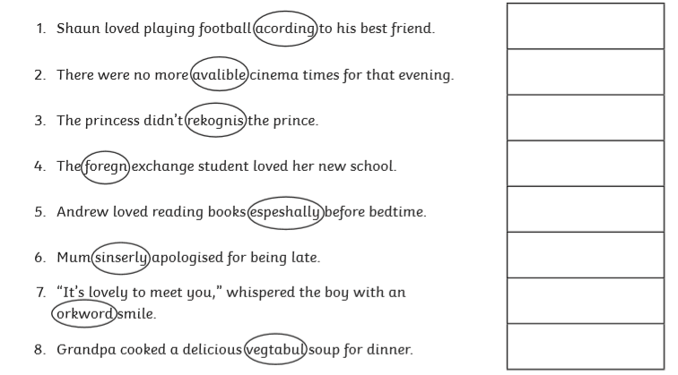

Literacy
Day 3: Spelling, Punctuation and Grammar
Activity

Challenge
- Create some of your own sentences with the incorrect spellings for an adult or other child to correct.
- Write down where each child went wrong with their spelling.

Literacy – day 3
SPaG mixed questions
Here are some questions on concepts that we have learnt earlier this year. Read each question carefully to answer the question accurately.
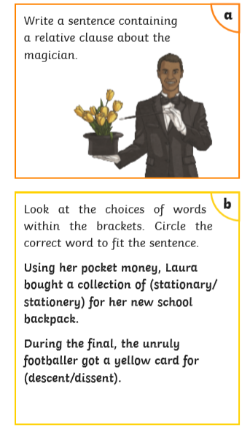
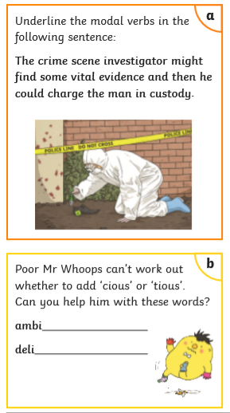

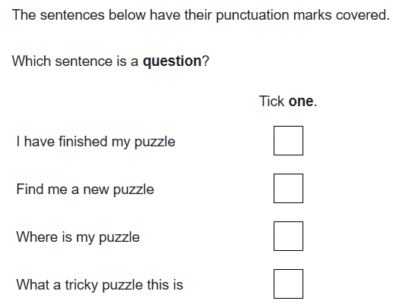
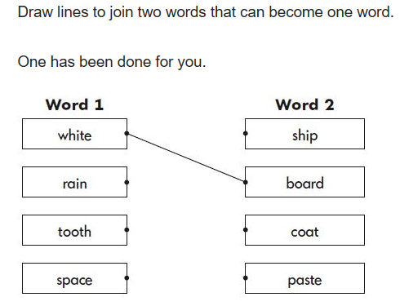

Literacy
Day 4: Writing
The Old Railway
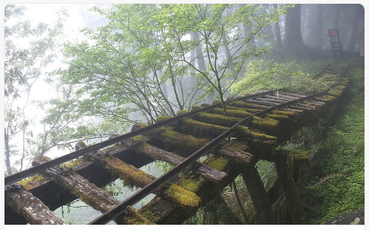
Activity 1: Read the introduction below
It had been many years since the shrill shriek of a steam train puffing along the track had been heard in these parts.
The Northern Railroad had been discontinued after the great disaster on June 11th, 1911. Ever since that day, the Railroad company had been nothing but a distant memory, a story to be told around the campfire late into the night.
As the group sat around their newly constructed camp, listening to the crackle of the flames as they licked up into the night, their minds wandered back to the stories they had heard from their fathers. So absorbed were they in the moment, and the mesmerizing glow of the fire, that it was hard to tell if the shrill shriek coming from the distance was part of their imaginations…
Activity 2: Answer the questions below in full sentences (remember the punctuation)
- What might have happened on June 11th, 1911?
- What stories have their fathers told them?
- Who is sitting around the campfire?
- Why are they out in the woods?
- What is the noise that they have heard?
- Was it part of their imaginations, or something more sinister?

Literacy
Day 5: Writing
The Old Railway
Activity 1: Recap the introduction from yesterday
Activity 2: Read the basic overview of the paragraph below.
- They sat in the woods.
- They lit a fire.
- They built a camp.
- They told stories.
- Then they heard a strange noise.
Use these 5 main events and add detail to create your own paragraph.
________________________________________________________________________________________________________________________________________________________________________________________________________________________________________________________________________________________________________________________________________________________________________________________________________________________________________________________________________________________________________________________________________________________________________________________________________________________________________________________________
Activity 3:
Can you draw a picture of what might have made the shrill, shrieking noise in the distance?

Reading – Day 1
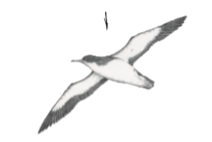
Read aloud, think aloud
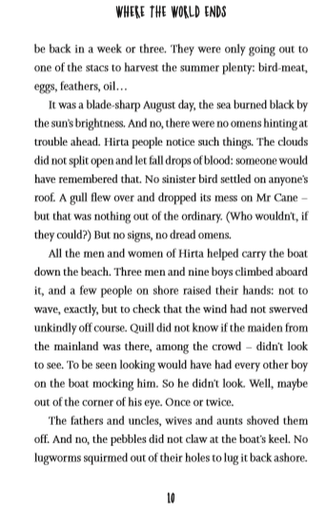

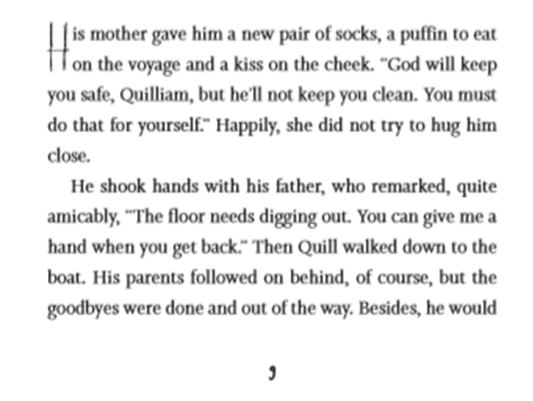

Challenge:
- Write down any words that you are unsure of and try to work out the definition.
- Summarise what you think this text is about in 5 key points.
- Find three nouns in the text.

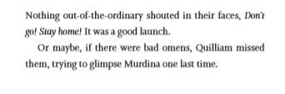

Reading – day 2
Vocabulary
Puffin  A type of bird | Lugworm  A large marine worm  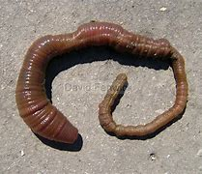 | Gull  A seabird  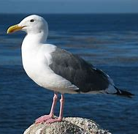 | Blade-sharp  As sharp as a blade  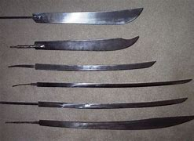  Or hot
Stacs to harvest  Meaning: to gather crops | Voyage  Meaning: a long journey involving travel by sea or space. | Remarked  Meaning: a comment | Amicably  Meaning: friendly
Glimpse  Meaning: a quick look | Launch  Meaning: to set something in motion | Swerved  Meaning: to change direction quickly | Maiden  Meaning: an unmarried young girl or woman
Mainland  Meaning: a place forming the main part of a country or continent | Mocking  Meaning: making fun of someone/something in a cruel way | Claw  Meaning: scratch or tear something with fingernails | Pebbles  Meaning: a small stone
Squirmed  Meaning: to wriggle or twist the body from side to side | Ashore  Meaning: on land | Shore  Meaning: the land at the edge of the sea | Omen  Meaning: an event/sign showing good or evil
Sinister  Meaning: that something evil or harmful will happen | Brightness  Meaning: how bright something is | Digging  Meaning: break up the earth/soil with a tool or a machine | Bird-meat  Meaning: meat from a bird

Challenge
  - Find and underline these words in the text.
  - Which word means an event showing good or evil?
  - Which word means to wriggle or twist?
  - Which word means to change direction quickly?
  - Name three types of animal from the grid above.
  - Which word means friendly?
  - Write three of these words into a sentence.

Reading – day 3
Retrieval

Retrieval
- Who gave him a new pair of socks?
- Who will keep Quilliam safe?
- What month was it?
- What did the clouds not do?
- Who helped to carry the boat?
- Did he look to find the maiden?

Reading – Day 4
Inference

Inference
- Why did mother give Quilliam a kiss on the cheek?
- Where do you think Quilliam was going?
- Why did people help to carry the boat?
- How do you think Quilliam was feeling at the end of the text?
- Why did he try to look for the maiden? How did he feel about her?
- Where do you think this person lived? Give evidence from the text.

Reading – day 5
Purpose and application
To write about a time when you went to the beach/seaside. If you haven’t ever been to the beach/seaside try to imagine it using the pictures below.
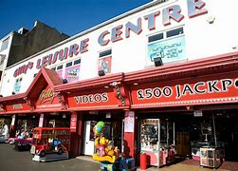
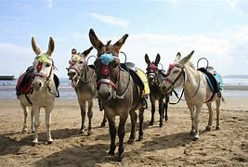
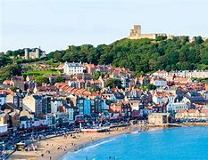

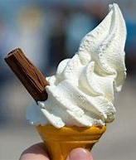
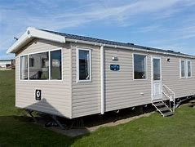
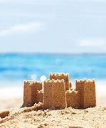
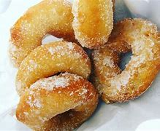

When writing answer/think about these questions:
  - How did you get there?
  - Who did you go with?
  - How did you feel when you were there?
  - What did you get up to?
  - Did you go for the day or stay over night?
  - Would you like to go again?
My day/weekend at the beach/seaside
______________________________________________________________________________________________________________________________________________________________________________________________________________________________________________________________________________________________________________________________________________________________________________________________________________________________________________________________________________________________________________________________________________________________________________________________________________________________________________________________________________________________________________________________________________________________________________________________________________________________________________________________________________________________________________________________________
Art
Activity: Use your sketching skills, to draw some of your favourite animals. Here are some examples to help.
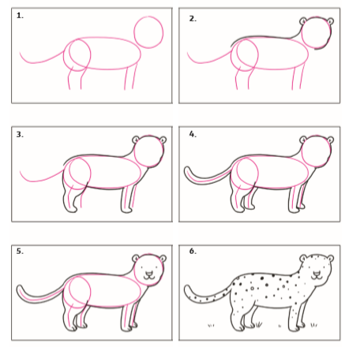
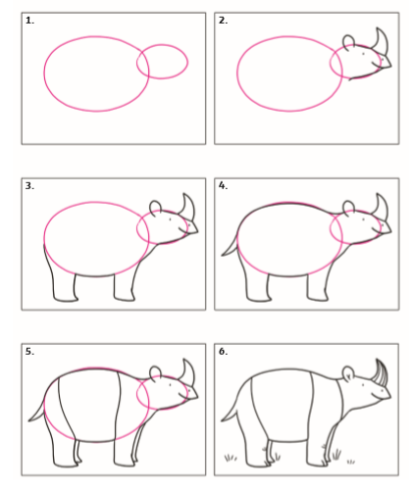

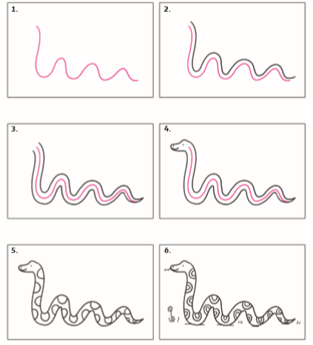
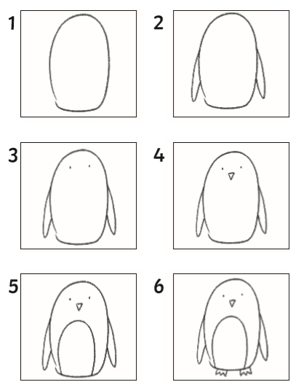

PE
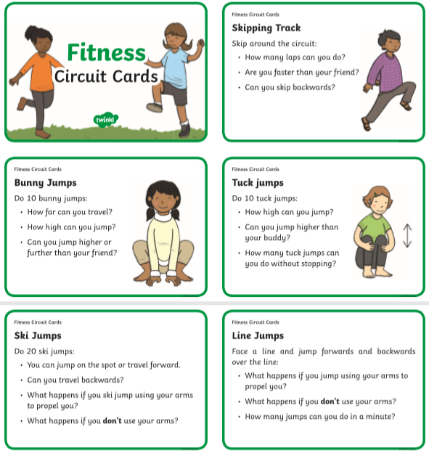

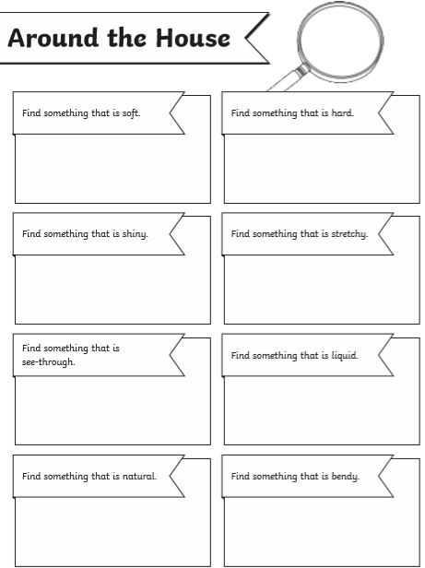
Scavenger hunt

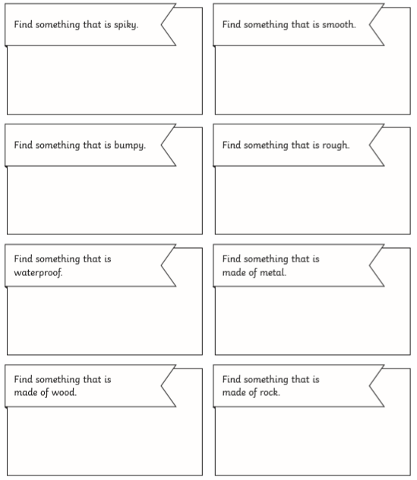

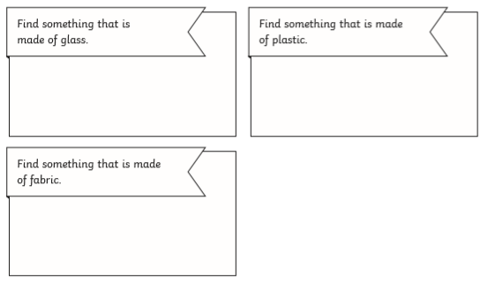

Science – The circulatory system
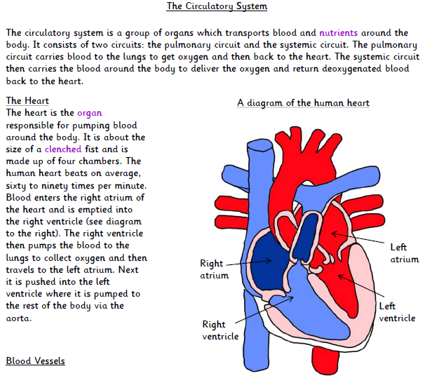

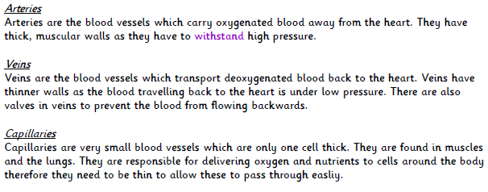

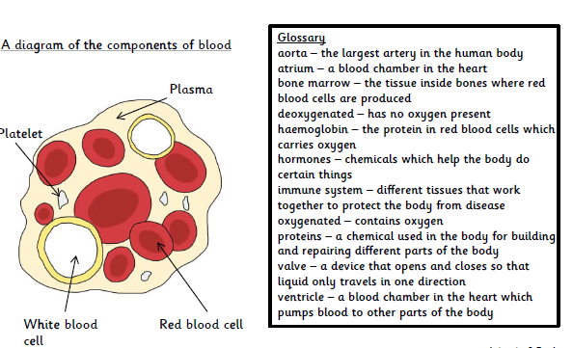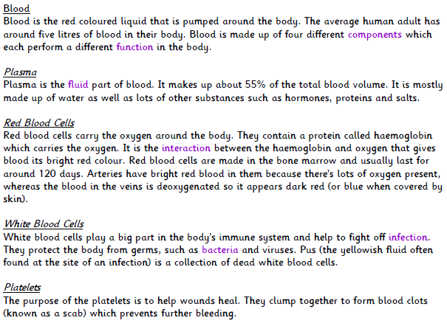

- Explain why you think the human heart has valves.

- What is the protein called in red blood cells?
_______________________________________________________________________________________________________________________
- Why are arteries thick and muscular?
___________________________________________________________________________________________________________________________
- 55% of blood is made-up of this substance. What is it called?
_______________________________________________________________________

- What is the function of white blood cells?
___________________________________________________________________________________________________________________________
- What is the difference between veins and arteries?
___________________________________________________________________________________________________________________________
- Why are there 4 chambers of the heart?
___________________________________________________________________________________________________________________________
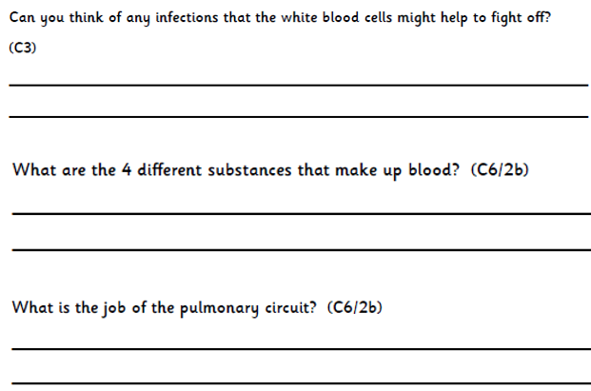

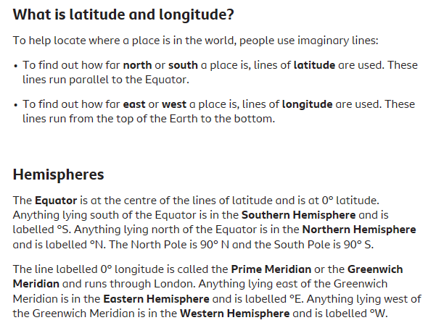
Geography
Page Break

