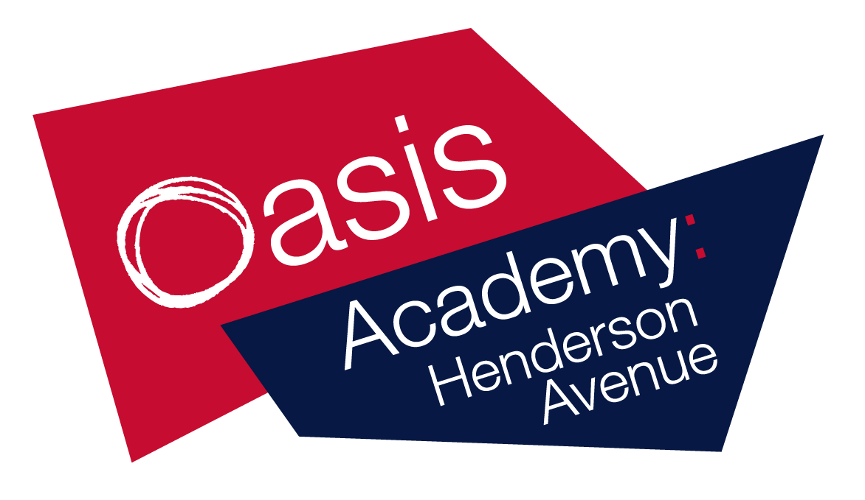

Name:_________
Year 5
Week 12
WB 22.06.20
BRONZE

children, parents and carers,

Although school is closed, we still want you to have access to high-quality
resources.

To help you and to provide online access to these resources, please take a look at the links below. They are all FREE!

Also please follow these your teacher on twitter for regular updates!
- @MarshallOAHA
- @GladmanMiss
- @MissWilliamsY5
Keep working hard and stay safe!
ukhosted14.renlearn.co.uk/6698989 - This is the website which children in years 3 to 6 use to quiz on books they have read. Children will now be able to access this from home, Monday to Friday.
https://ttrockstars.com/ - This is a website where children are able to practise their times tables.
Lovereading4kids.co.uk - An extensive library of books, including classics and brand new released, with reviews, plots and downloadable extracts. Sign up for free.
https://pages.sumdog.com/ This is a website where children can complete maths and spelling practise.
https://www.bbc.co.uk/bitesize/levels/zbr9wmn A website where children and parents can access all curriculum areas.
Twinkl.co.uk/offer A website where children and parents can access all curriculum areas. To access enter the code UKTWINKLHELPS
https://www.duolingo.com A website where children can learn a new language. At OAHA we teach French.
https://classroomsecrets.co.uk/ A website where children can access all curriculum areas.
https://shop.scholastic.co.uk/homelearning A pack of work for home learning.
https://whiterosemaths.com/ A website full of maths resources.
https://2simple.com/free-access/ A website full of cross-curricular activities and resources.
Pobble365.com A website with writing ideas and photo stimuli.
https://www.spellingshed.com/en-gb Sign up for free!
https://www.mathshed.com/en-gb Sign up for free!

Art
Activity: Use your sketching skills, to draw some of your favourite animals. Here are some examples to help.
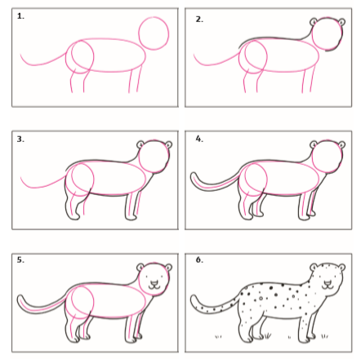
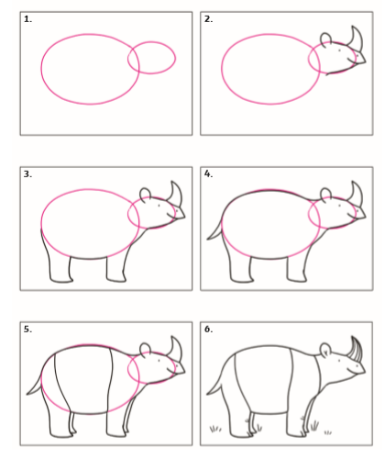

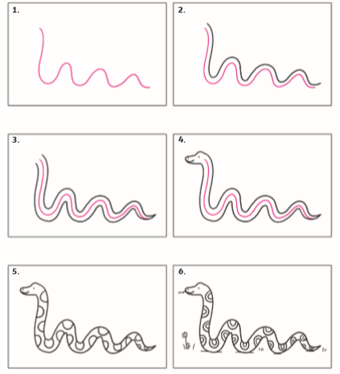
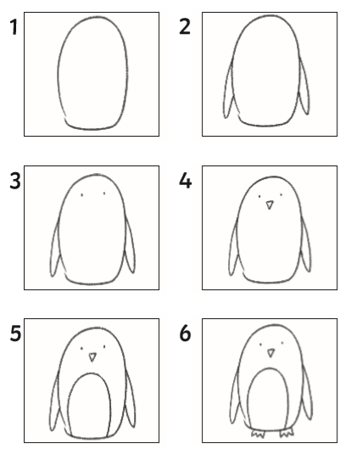

PE
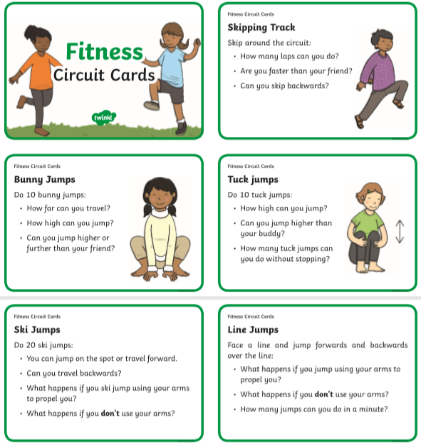

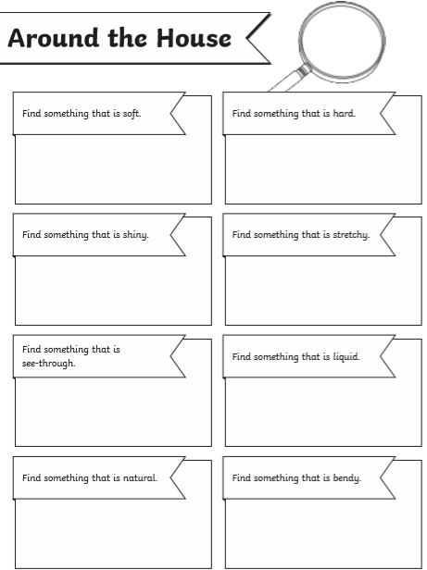
Scavenger hunt

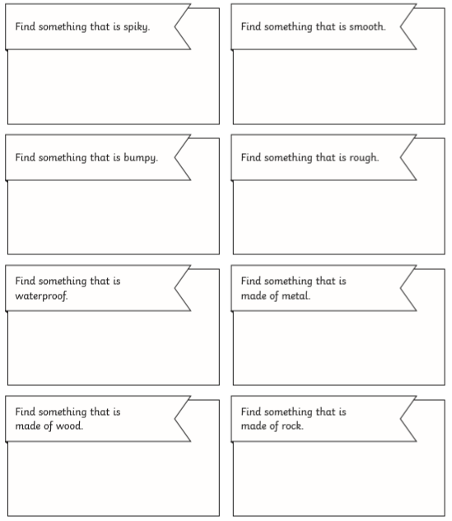

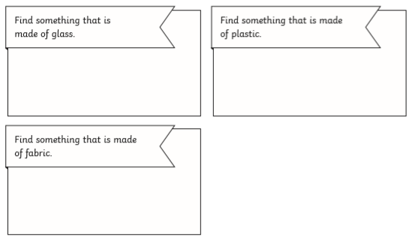

Literacy
Day 1: Spelling, Punctuation and Grammar
Activity
These are non-negotiable spellings to learn in year 5/6. Each day practise all ten spellings (using look, cover, write, check).
 | Day 1 | Day 2 | Day 3 | Day 4 | Day 5
heard
arrive
breath
build
busy
early
fruit

Challenge
- Write a definition for 5 of these words.
- Write 3 of these words into a sentence.
- Try and include some of these words into your writing this week!

Literacy
Day 2: Spelling, Punctuation and Grammar
Activity
Correct the spelling mistake.
The spellings mistakes in these sentences have been underlined. Write down the correct spelling next to the sentence. All of the correct spellings are in the word list from day 1.

- I hurd the story about the old railway. __________________
- You need to arive on time to school. ____________________
- Humans breeth in oxygen and out carbon dioxide. _________
- Yesterday, we bilt a sandcastle on the beach. _____________
- “I hope you’re not too bisy today!’ called the girl. _________
- You should arrive urly just incase you miss the bus. _______
- The doctor told us to keep eating froot. ________________
Literacy
Day 3: Spelling, Punctuation and Grammar
Activity
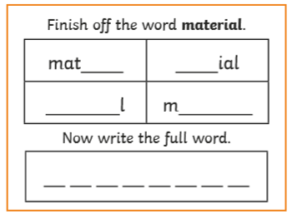
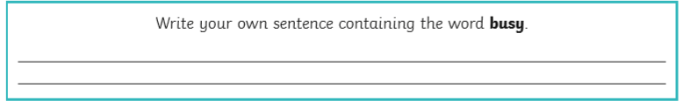
Here are four mixed questions on concepts that we have learnt earlier this year. Read each question carefully to answer the question accurately.

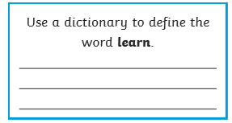
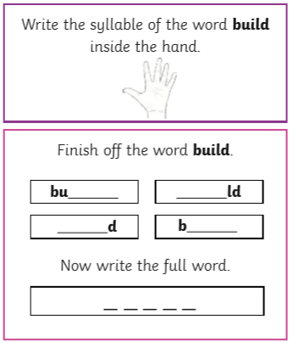

Literacy
Day 4: Writing
The Old Railway
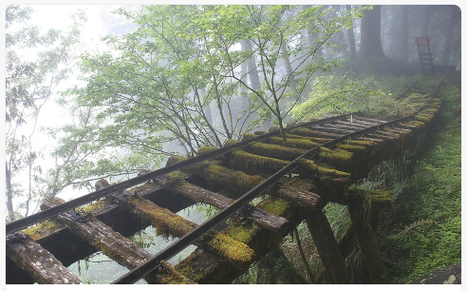Activity 1: Read the introduction below
It had been many years since the shrill shriek of a steam train puffing along the track had been heard in these parts.
The Northern Railroad had been discontinued after the great disaster on June 11th, 1911. Ever since that day, the Railroad company had been nothing but a distant memory, a story to be told around the campfire late into the night.
As the group sat around their newly constructed camp, listening to the crackle of the flames as they licked up into the night, their minds wandered back to the stories they had heard from their fathers. So absorbed were they in the moment, and the mesmerizing glow of the fire, that it was hard to tell if the shrill shriek coming from the distance was part of their imaginations…

Activity 2: Answer the question below in full sentences (remember the punctuation)
- What might have happened on June 11th, 1911?
I think….
I believe..
On June 11th 1911, I think that..
In summer 1911. I believe..

Literacy
Day 5: Writing
The Old Railway
Activity 1: Read the introduction below
It had been many years since the shrill shriek of a steam train puffing along the track had been heard in these parts.
The Northern Railroad had been discontinued after the great disaster on June 11th, 1911. Ever since that day, the Railroad company had been nothing but a distant memory, a story to be told around the campfire late into the night.
As the group sat around their newly constructed camp, listening to the crackle of the flames as they licked up into the night, their minds wandered back to the stories they had heard from their fathers. So absorbed were they in the moment, and the mesmerizing glow of the fire, that it was hard to tell if the shrill shriek coming from the distance was part of their imaginations…
Activity 2:
Can you draw a picture of what this setting may look like?
Who is in the setting? Where are they? What did they hear? Where might be making this shrill shriek be coming from?

Science
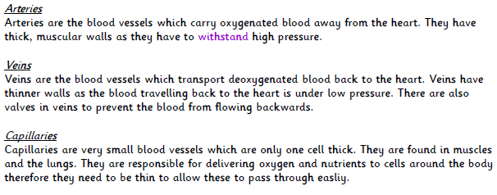
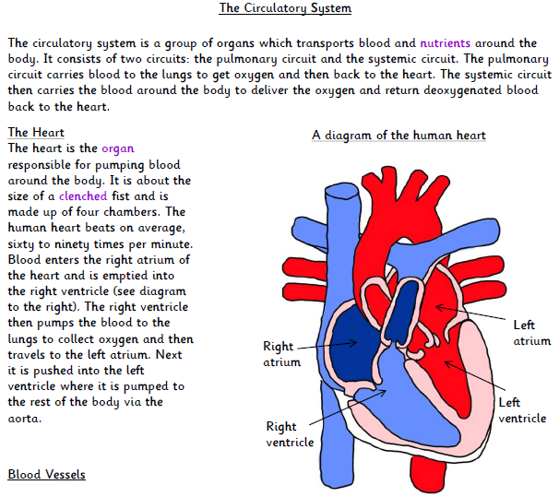

•
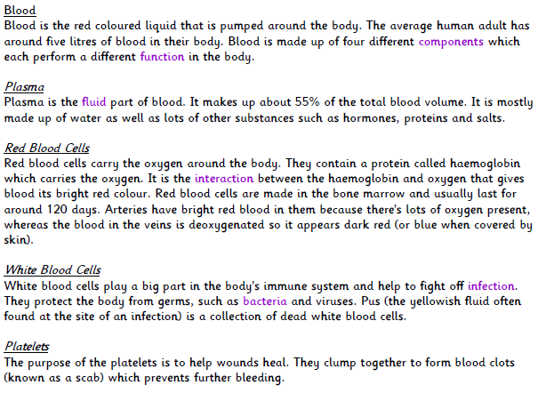

- What does the heart do for the human body?
__________________________________________________________________________________________________________________________
- How big is the average human heart?
_______________________________________
______________________________________________________________________________
- How many chambers does it have?
______________________________________________________________________________
- Write down 1 adjective to describe the arteries.
______________________________________________________________________________
- What is the function of veins?
______________________________________________________________________________
______________________________________________________________________________
- Where are capillaries found?
______________________________________________________________________________
- How many different parts is blood made from?
______________________________________________________________________________
- Why do we need white blood cells?
______________________________________________________________________________
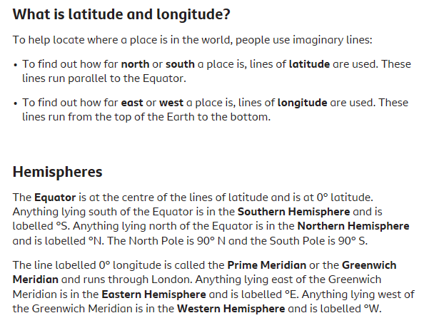
Geography
Page Break

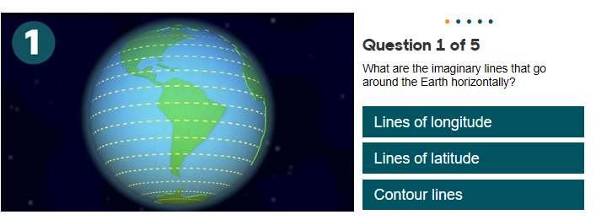

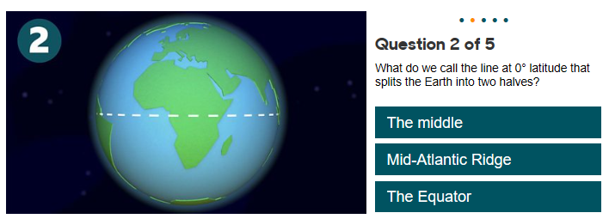

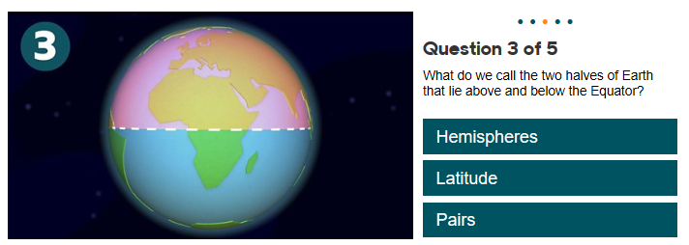

Reading – day 1
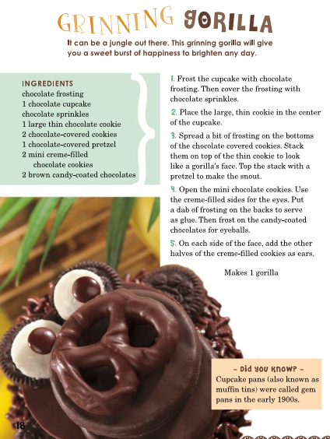
Read aloud, think aloud

Challenge
- Read and text mark as you go along.
- Underline or circle any words that you are unsure of.
- Ask an adult to time how long it takes you to read this text.

Reading – day 2
Vocabulary and background
Gorilla  A type of animal  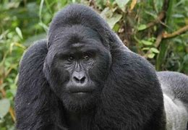 | Grinning  Smile broadly | Frosting  Normally a cream glaze for the top of a cake  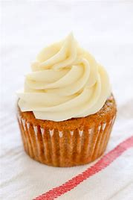 | Pretzel  A sugary treat  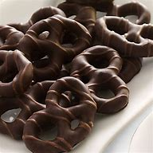
Cream filled  Filled with cream  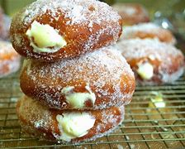 | Centre  In the middle  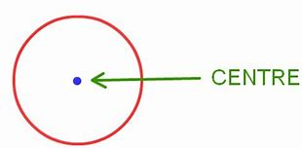 | Brighten  Become light  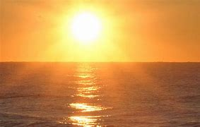 | Jungle  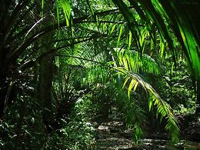
Burst  Break open apart suddenly  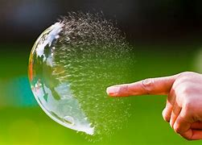 | Stack  Pile of objects | Snout  Nose and mouth of an animal  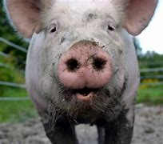 | Dab  A light touch

Challenge
  - What is a snout?
  - What is a grin?
  - Which word means to put things on top of one another?
  - Which word means to break open suddenly?
  - What is the centre?
Put two of these into a sentence.

Reading – day 3
Answer the questions below:
- What type of text is this?
- What is the title of this text?
- How many gorilla’s does this recipe make?
- How many cookies do you need?
- What is the second step?
- What is the last step?
Retrieval

Reading – day 4
Inference
Answer the questions below:
- Why would somebody create this piece of text?
- Who do you think would use/read this piece of text?
- Why does it have numbers at the beginning of some pieces of text?
- Why does it have a picture?
- What is often included into the ‘Did you know?’ box?

Reading – day 5
Purpose and application
Can you write your own set of instructions?
It could be a recipe, how to ride a bike or how to log onto a computer. Anything that interests you!
Good luck and have fun writing.

