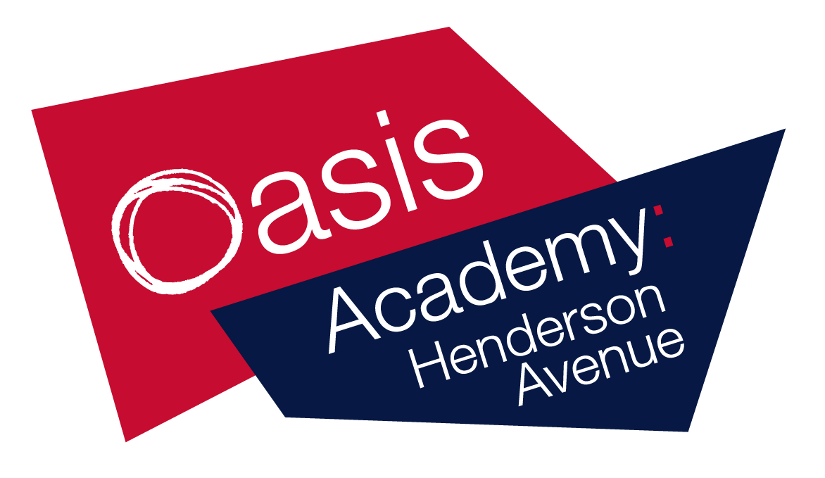

Name:_________
Year 5
Week 7
WB 11.5.2020

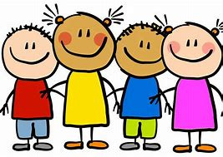
Dear children, parents and carers,

Although school is closed, we still want you to have access to high-quality
resources.

To help you and to provide online access to these resources, please take a look at the links below. They are all FREE!

Also please follow these your teacher on twitter for regular updates!
- @MarshallOAHA
- @GladmanMiss
- @MissWilliamsY5
Keep working hard and stay safe!
ukhosted14.renlearn.co.uk/6698989 - This is the website which children in years 3 to 6 use to quiz on books they have read. Children will now be able to access this from home, Monday to Friday.
https://ttrockstars.com/ - This is a website where children are able to practise their times tables.
Lovereading4kids.co.uk - An extensive library of books, including classics and brand new released, with reviews, plots and downloadable extracts. Sign up for free.
https://pages.sumdog.com/ This is a website where children can complete maths and spelling practise.
https://www.bbc.co.uk/bitesize/levels/zbr9wmn A website where children and parents can access all curriculum areas.
Twinkl.co.uk/offer A website where children and parents can access all curriculum areas. To access enter the code UKTWINKLHELPS
https://www.duolingo.com A website where children can learn a new language. At OAHA we teach French.
https://classroomsecrets.co.uk/ A website where children can access all curriculum areas.
https://shop.scholastic.co.uk/homelearning A pack of work for home learning.
https://whiterosemaths.com/ A website full of maths resources.
https://2simple.com/free-access/ A website full of cross-curricular activities and resources.
Pobble365.com A website with writing ideas and photo stimuli.
https://www.spellingshed.com/en-gb Sign up for free!
https://www.mathshed.com/en-gb Sign up for free!

Bronze
Reading task 1 - Background knowledge and vocabulary
Book name – Worst class in the world
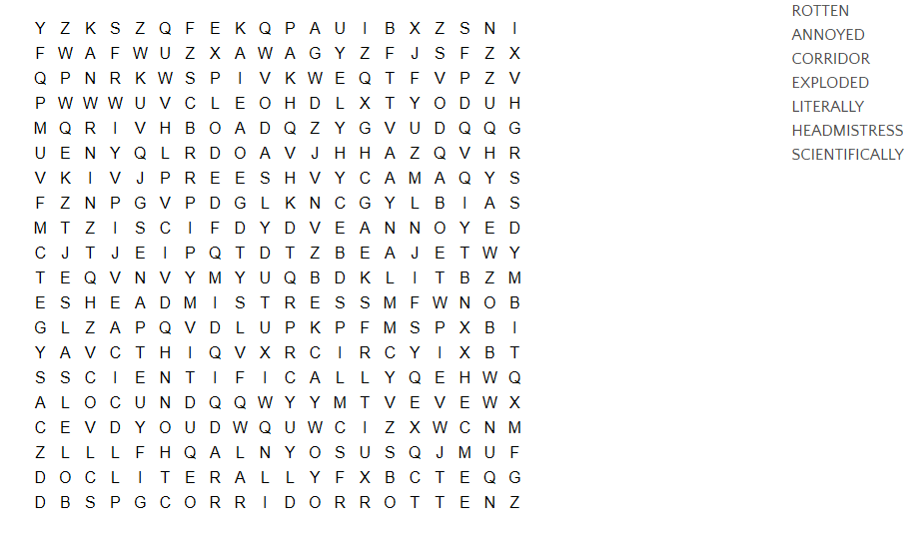

Reading – task 2
Read aloud, think aloud.
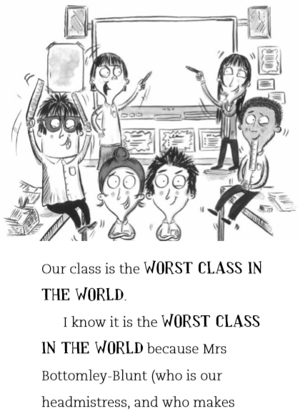
Book name – Worst class in the world
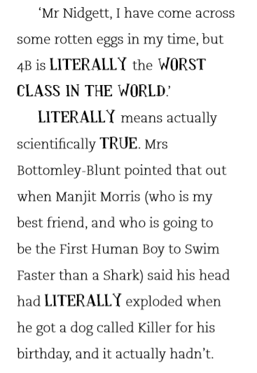
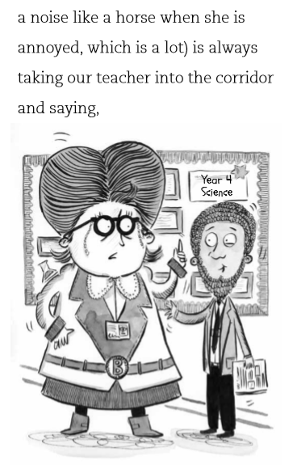

Reading – Task 3
Retrieval
Book name – Worst class in the world.

- Who is the headmistress?
- What noise does Mrs Bottomley-Blunt make?
- Which class is the worst in the world?
- Who is going to be the first human boy to swim faster than a shark?
- Who got a dog called killer for his birthday?

Reading - Task 4
Inference
Book – Worst class in the world

- Why do you think this class are the worst class in the world?
- Who says that 4B are the worst class in the world?
- How could class 4B be better?
- How do you think the teacher feels about their class?

Bronze
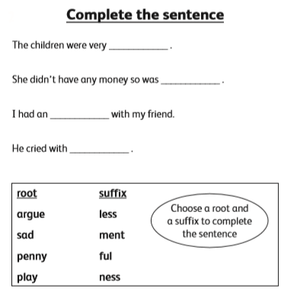
Literacy – Task 1
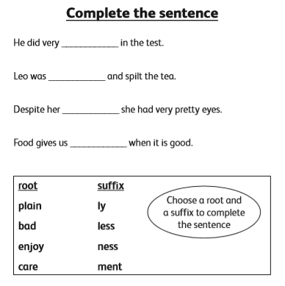

Literacy – Task 2
Writing task
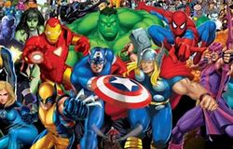
If you could have one superpower what would it be and why? Explain why you have chosen it, what you would do with it and how it would change your life.
Sentence starters and vocabulary:
- I would choose……because…
- It would change my life ……..
- With this power, I would…..
- I have chosen this because….
Challenge: Create a superhero and write a story about your superhero.
Types of superpowers:
- Invisibility
- Flight
- X-Ray Vision
- Shapeshifting
- Super strength
- Time travel

___________________________________________________________________________________________________________________________________________________________________________________________________________________________________________________________________________________________________________________________________________________________________________________________________________________________________________________________________________________________________________________________________________________________________________________________________________________________________________________________________________________________________________________________________________________________________________________________________________________________________________________________________________________________________________________________________________________________________________________________________________________________________________________________________________________________________________________________________________________________________________________________________________________________________________________________________________________________________________________________________________________________________________________________________________________________________________________________________________________________________________________________________________________________________________________________________________________________________________________________________________________________________________________________________________________________________________________________________________________________
Literacy – task 3
Writing
Think about something that really annoys or bothers you. Write about what it is and why it bothers you. What can you do to make it less irritating?
Sentence starters:
- I am annoyed by….
- The things that bothers me is….
- I could try to….
- I wish ……. would happen because….
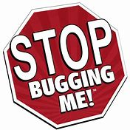
Things that could bother you:
- Siblings
- What is going on in the world at the moment.
- Bedtime
- Rules
- Friends

__________________________________________________________________________________________________________________________________________________________________________________________________________________________________________________________________________________________________________________________________________________________________________________________________________________________________________________________________________________________________________________________________________________________________________________________________________________________________________________________________________________________________________________________________________________________________________________________________________________________________________________________________________________________________________________________________________________________________________________________________________________________________________________________________________________________________________________________________________________________________________________________________________________________________________________________________________________________________________________________________________________________________________________________________________________________________________________________________________________________________________________________________________________________________________________________________________________________________________________________________________________________________________________________________________________________
Literacy – Task 4
SPAG
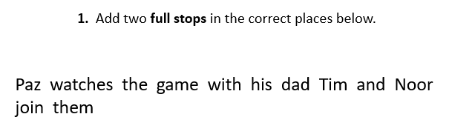
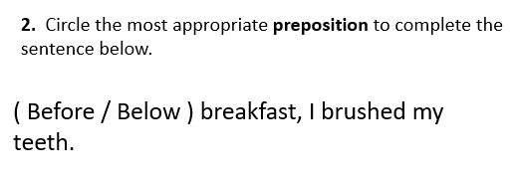
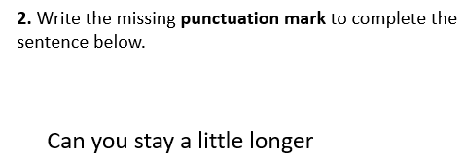
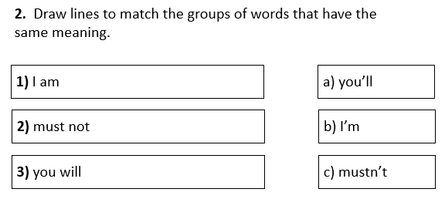

Science – practical activity
How to make a lava lamp!
Things you will need:
- A cup/clear plastic bottle
- ¼ cup of oil (any type)
- Food colouring (optional)
- Water
- 1 tsp Salt
Instructions:
- Fill the glass/bottle about ¾ full of water.
- Add about 5 drops of food colouring.
- Slowly pout the vegetable oil in.
- Sprinkle the salt on top of the oil.
Now watch the blobs of lava move up and down your glass. If you liked that, add another teaspoon of salt to keep the effect going.
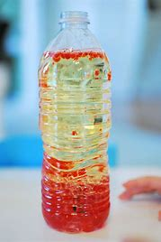
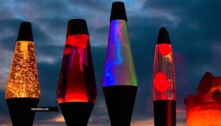

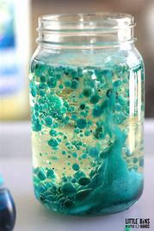
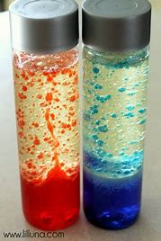

Design Technology
Create your own rollercoaster
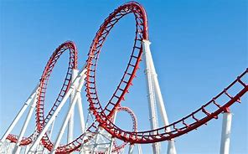
For this task, you can design and draw it, make it or describe what it would look like. Think about these things:
- What is its purpose? E.g. to scare
- Who is it aimed at?
- Where will it be placed?
- How many loops will it have?
- How fast will it go?
- What is it called?
- How high is it?
- How many people can go on it at one time?
- Does it have a theme? E.g. dinosaurs Does the rollercoaster go through water?
Complete your design and any instructions below.

Mindfulness and thinking time
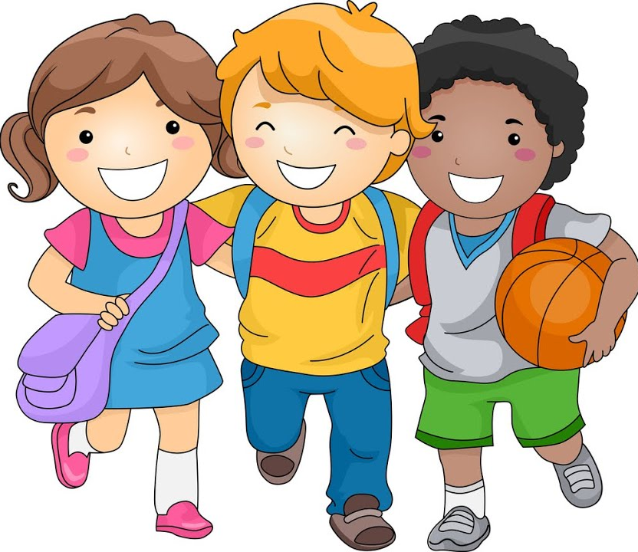
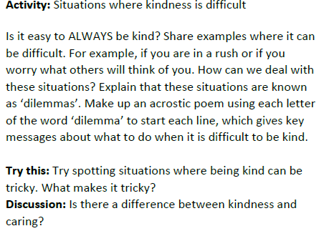
Write the ingredients of a good friendship. This could be as a list, in sentences or as a whole paragraph. Explain what a good friendship looks like and how it makes you feel.
--------------------------------------------------------------------------------------------

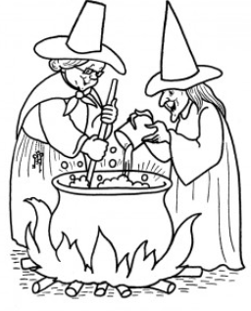
Mindfulness colouring

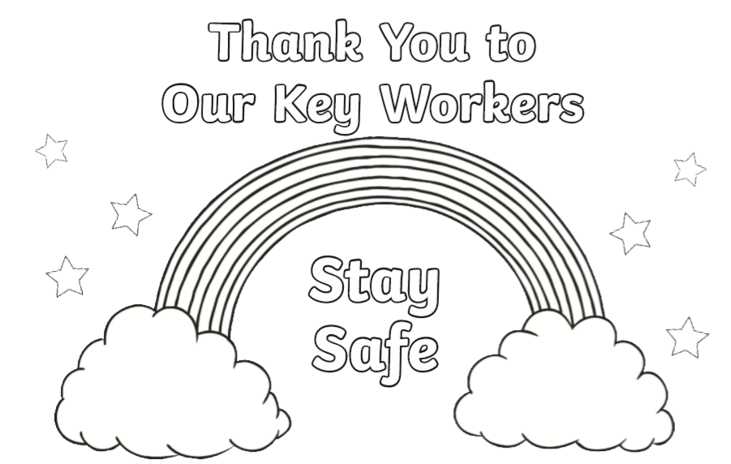
Mindfulness colouring

