Year 6
Home Learning Pack: 2
Subject: Literacy

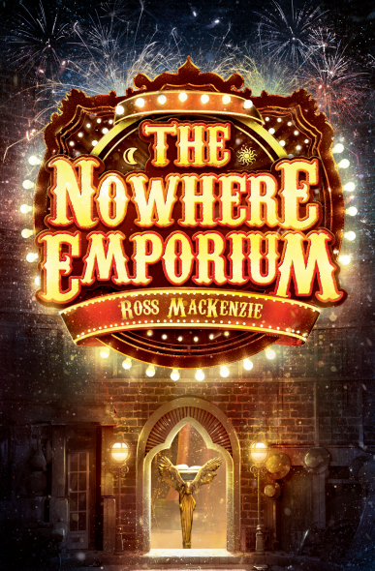

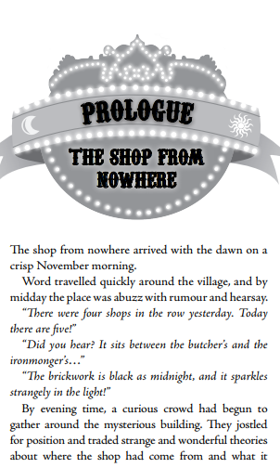

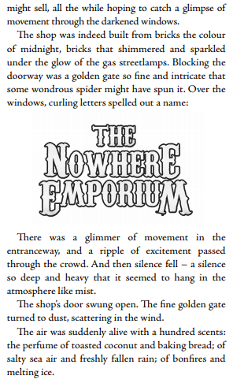

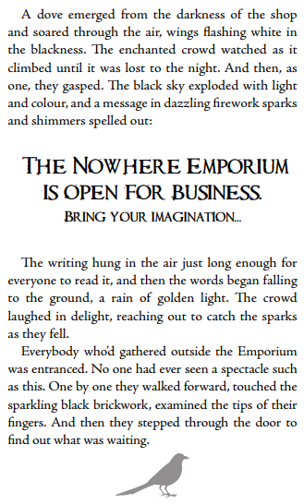

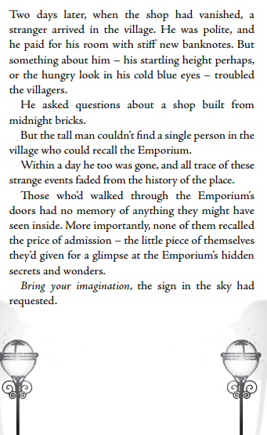

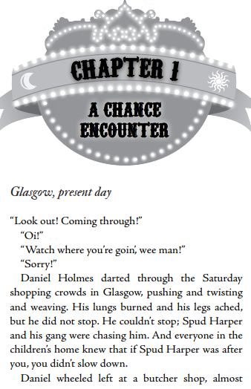
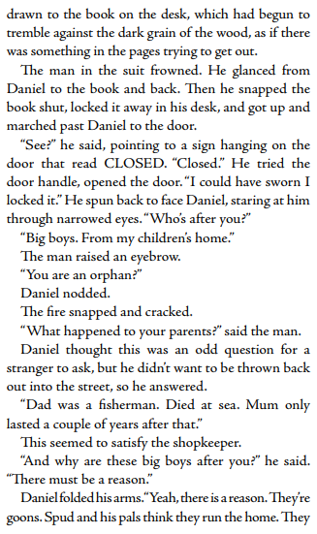

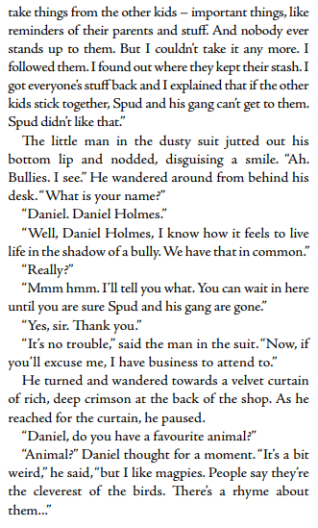

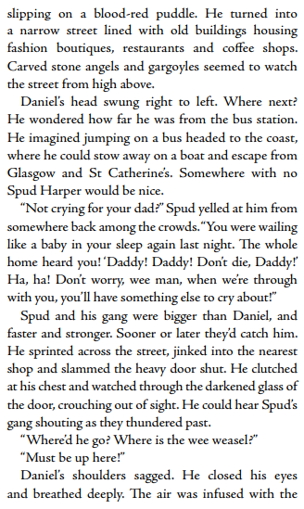

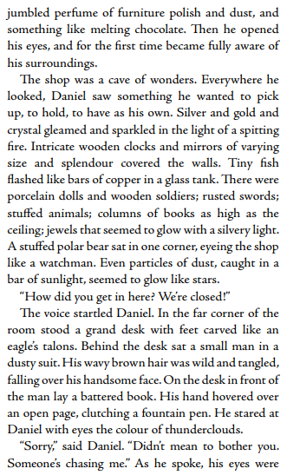

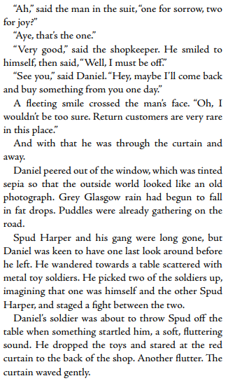

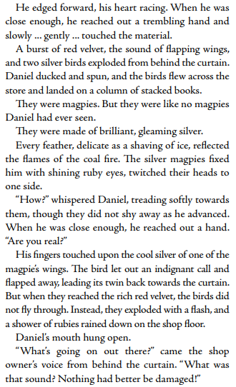

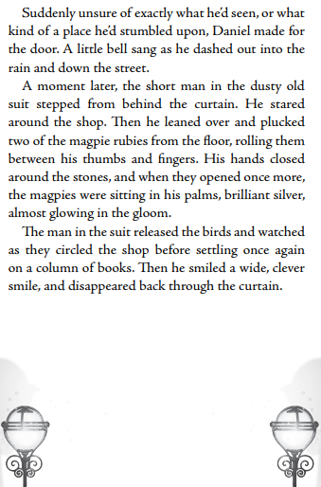

LITERACY DAY 1
Reading
Read the Prologue. Collect descriptions of the shop.
Writing
You are in the crowd on the evening of the opening. Write a diary entry of your experience.

____________________________________________________________________________________________________________________________________________________________________________________________________________________________________________________________________________________________________________________________________________________________________________________________________________________________________________________________________________________________________________________________________________________________________________________________________________________________________________________________________________________________________________________________________________________________________________________________________________________________________________________________________________________________________________________________________________________________________________________________________________________________________________________________________________________________________________________________________________________________________________________________________________________________________________________________________________________________________________________________________________________________________________________________________________________________________________________________________________________________________________________________________________________________
_______________________________________________________________________________________________________________________________________________________________________________________________________________________________________________________________________________________________________________________________________________________________________________________

LITERACY DAY 2
Reading
Order the events of the Prologue.

Writing
Write a summary in fewer than 100 words.

____________________________________________________________________________________________________________________________________________________________________________________________________________________________________________________________________________________________________________________________________________________________________________________________________________________________________________________________________________________________________________________________________________________________________________________________________________________________________________________________________________________________________________________________________________________________________________________________________________________________________________________________________________________________________________________________________________________________________________________________________________________________________________________________________________________________________________________________________________________________________________________________________________________________________________________________________________________________________________________________________________________________________________________________________________________________________________________________________________________________________________________________________________________________
_______________________________________________________________________________________________________________________________________________________________________________________________________________________________________________________________________________________________________________________________________________________________________________________
LITERACY DAY 3
Reading
Read Chapter 1.

Writing
Draw a picture of the ‘man in the suit’. Remember to use descriptions from the text to help you.
________________________________________________________________________________________________________________________________________________________________________________________________________________________________________________________________________________________________________________________________________________________________________________________________________________________________________________________________________________________________________________________________________________________________________________________________________________________________________________________________________________________________________________________________________________________________________________________________________________________________________________________________________________________________________________________________________________________________________________________________________________________________________________________________________________________________________________________________________________________________________________________________________________________________________________________________________________________________________________________________________________________________________________________________________________________________________________________________________________________________
________________________________________________________________________________________________________________________________________________________________________________________________________________________________________________________________________________________________________________________________________________________________________
LITERACY DAY 4
Reading
Describe the magpies. Remember to use the text to help you.

Writing
Design your own magical animal. What is it made of? What is special and magical about it?
____________________________________________________________________________________________________________________________________________________________________________________________________________________________________________________________________________________________________________________________________________________________________________________________________________________________________________________________________________________________________________________________________________________________________________________________________________________________________________________________________________________________________________________________________________________________________________________________________________________________________________________________________________________________________________________________________________________________________________________________________________________________________________________________________________________________________________________________________________________________________________________________________________________________________________________________________________________________________________________________________________________________________________________________________________________________________________________________________________________________________________________________________________________________
_______________________________________________________________________________________________________________________________________________________________________________________________________________________________________________________________________________________________________________________________________________________________________________________

LITERACY DAY 5
Reading
There is very little description of what Daniel Holmes looks like. Use your inference skills and imagination to write a description or draw him.

Writing
Design a poster inviting people to the Nowhere Emporium.
____________________________________________________________________________________________________________________________________________________________________________________________________________________________________________________________________________________________________________________________________________________________________________________________________________________________________________________________________________________________________________________________________________________________________________________________________________________________________________________________________________________________________________________________________________________________________________________________________________________________________________________________________________________________________________________________________________________________________________________________________________________________________________________________________________________________________________________________________________________________________________________________________________________________________________________________________________________________________________________________________________________________________________________________________________________________________________________________________________________________________________________________________________________________
_______________________________________________________________________________________________________________________________________________________________________________________________________________________________________________________________________________________________________________________________________________________________________________________

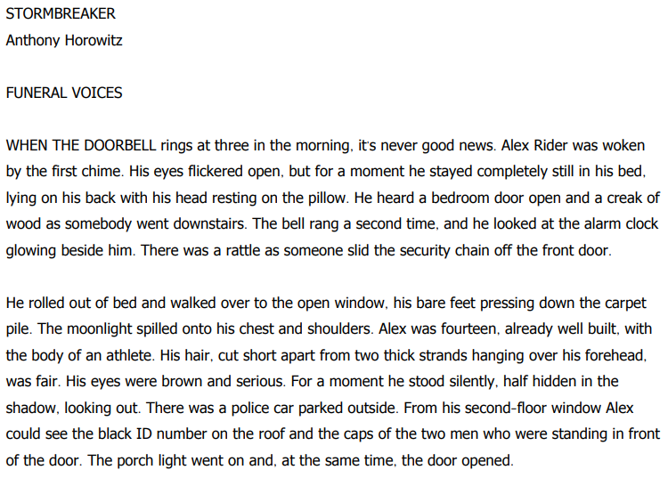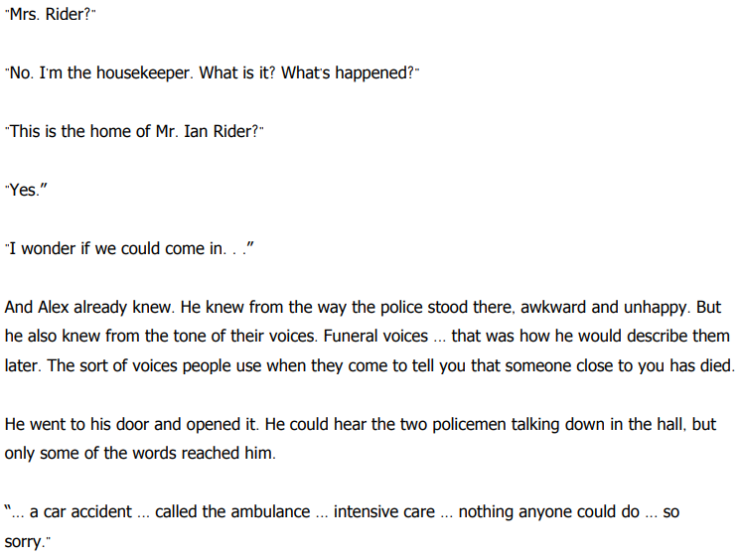
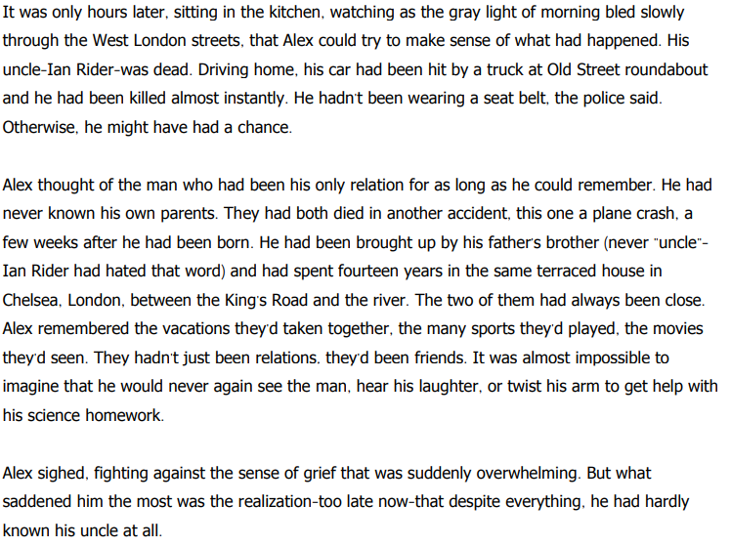
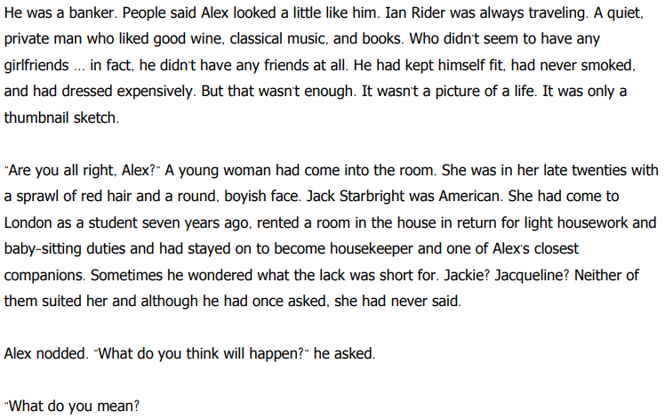

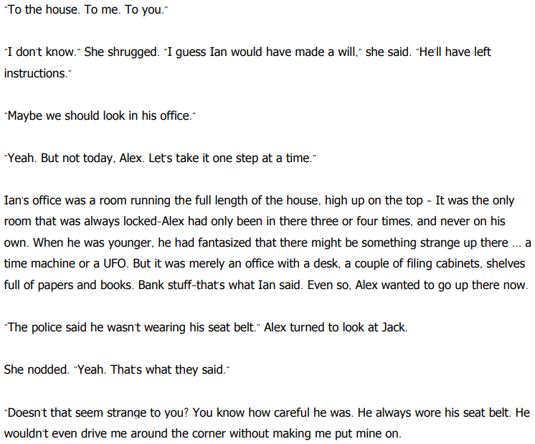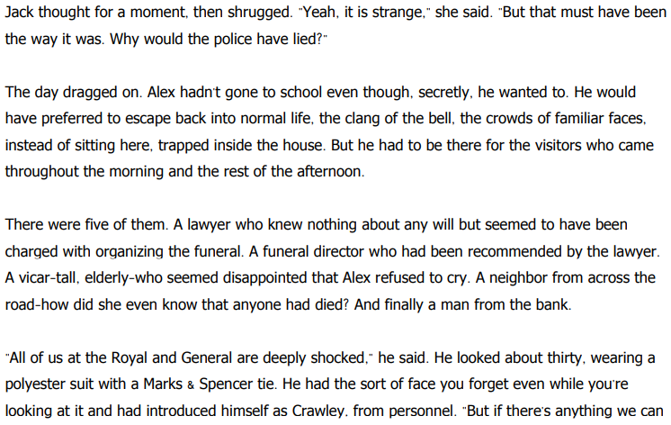

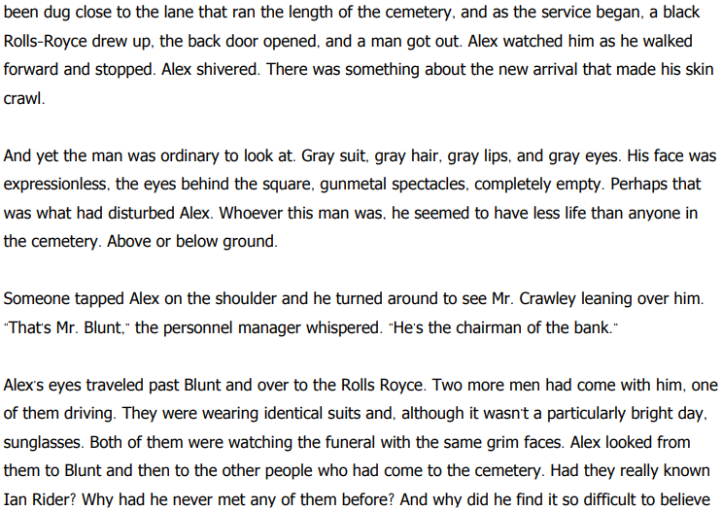
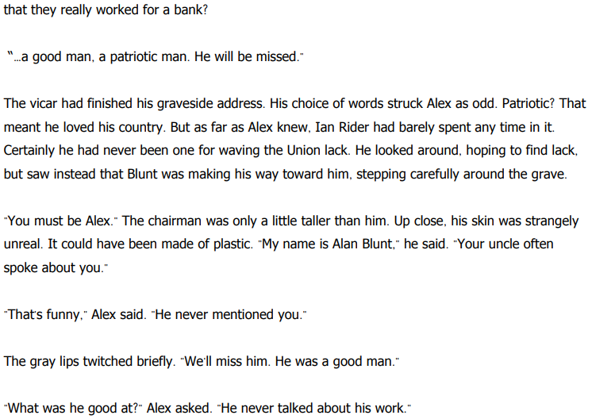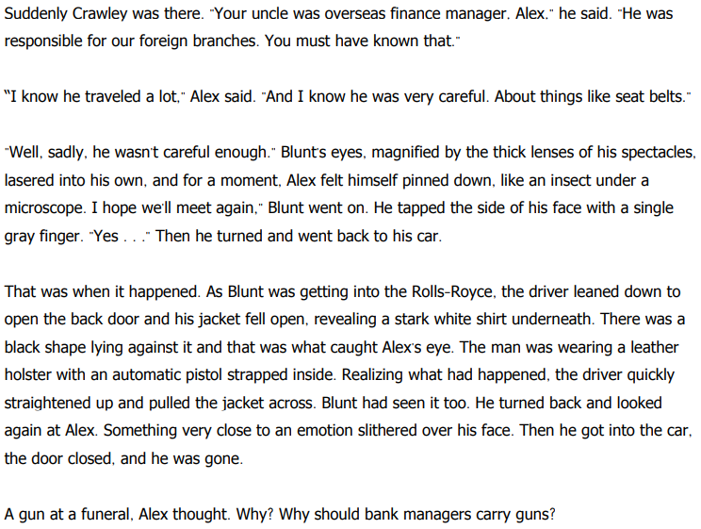
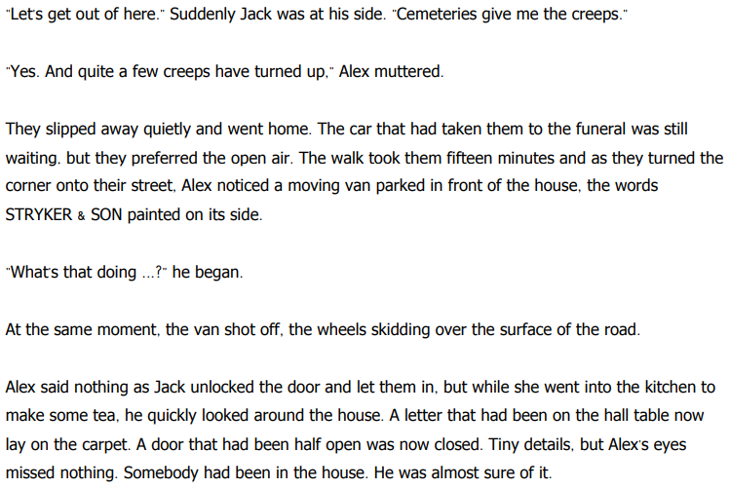
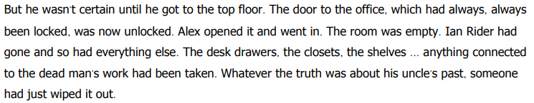

LITERACY DAY 6
Reading
Read the whole of the chapter and discuss it with someone at home. What questions does it raise? What does it make you think?
Writing
Write Alex’s diary for the day the police came to tell him his uncle had died.

____________________________________________________________________________________________________________________________________________________________________________________________________________________________________________________________________________________________________________________________________________________________________________________________________________________________________________________________________________________________________________________________________________________________________________________________________________________________________________________________________________________________________________________________________________________________________________________________________________________________________________________________________________________________________________________________________________________________________________________________________________________________________________________________________________________________________________________________________________________________________________________________________________________________________________________________________________________________________________________________________________________________________________________________________________________________________________________________________________________________________________________________________________________________
_______________________________________________________________________________________________________________________________________________________________________________________________________________________________________________________________________________________________________________________________________________________________________________________
LITERACY DAY 7
Reading
Character mind map for Alex Rider.
Writing
Write a police incident report for the car crash which killed Ian rider.

personality family/connections

IAN RIDER

history other

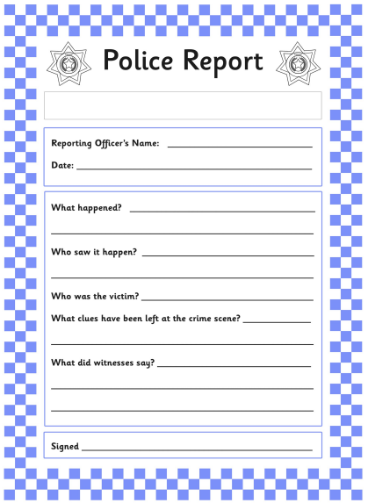

LITERACY DAY 8
Reading
Character mind map for Ian Rider.
Writing
If Jack goes back to America, imagine the letter Alex would write to her.

personality family/connections

ALEX RIDER

history other

Dear Jack,
_______________________________________________________________________________________________________________________________________________________________________________________________________________________________________________________________________________________________________________________________________________________________________________________________________________________________________________________________________________________________________________________________________________________________________________________________________________________________________________________________________________________________________________________________________________________________________________________________________________________________________________________________________________________________________________________________________________________________________________________________________________
LITERACY DAY 9
Reading
Create a timeline of events from this chapter.
Writing
This story is called ‘Stormbreaker’. Predict what or who Stormbreaker is and how Alex is connected to it.

I predict
_________________________________________________________________________________________________________________________________________________________________________________________________________________________________________________________________________________________________________________________________________________________________________________________________________________________________________________________________________________________________________________________________________________________________________________________________________________________________________________________________________________________________________________________________________________________________________________________________________________________________________________________
LITERACY DAY 10
Reading
Summarise Alex’s life up to this point, in fewer than 200 words.
Writing
Write the next chapter. What will happen to Alex? Use the clues he has uncovered to begin to solve the mystery of his uncle’s death.

_________________________________________________________________________________________________________________________________________________________________________________________________________________________________________________________________________________________________________________________________________________________________________________________________________________________________________________________________________________________________________________________________________________________________________________________________________________________________________________________________________________________________________________________________________________________________________________________________________________________________________________________
_________________________________________________________________________________________________________________________________________________________________________________________________________________________________________________________________________________________________________________________________________________________________________________________________________________________________________________________________________________________________________________________________________________________________________________________________________________________________________________________________________________________________________________________________________________________________________________________________________________________________________________________
_________________________________________________________________________________________________________________________________________________________________________________________________________________________________________________________________________________________________________________________________________________________________________________________________________________________________________________________________________________________________________________________________________________________________________________________________________________________________________________________________________________________________________________________________________________________________________________________________________________________________________________________
_________________________________________________________________________________________________________________________________________________________________________________________________________________________________________________________________________________________________________________________________________________________________________________________________________________________________________________________________________________________________________________________________________________________________________________________________________________________________________________________________________________________________________________________________________________________________________________________________________________________________________________________
_________________________________________________________________________________________________________________________________________________________________________________________________________________________________________________________________________________________________________________________________________________________________________________________________________________________________________________________________________________________________________________________________________________________________________________________________________________________________________________________________________________________________________________________________________________________________________________________________________________________________________________________

