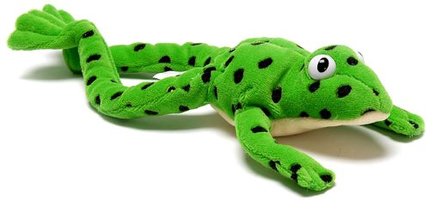
F2 Daily Phonics – Read Write Inc

Monday – Can you point to the sounds on the sound chart?
Tuesday – Practise the first 5 sounds. Read the rhyme that goes with the sounds to remember how to say them. You could practise writing them with chalk, in the sand, in the mud, with paintbrushes, pens, crayons.
Wednesday – Practise reading the CVC words by sounding them out using the speed sound buttons underneath.
Thursday – Can you find items in your home which begin with the letters m, a, s, d, t.
Friday – Practise the 6 words and try to sound them out and read them with support from an adult.
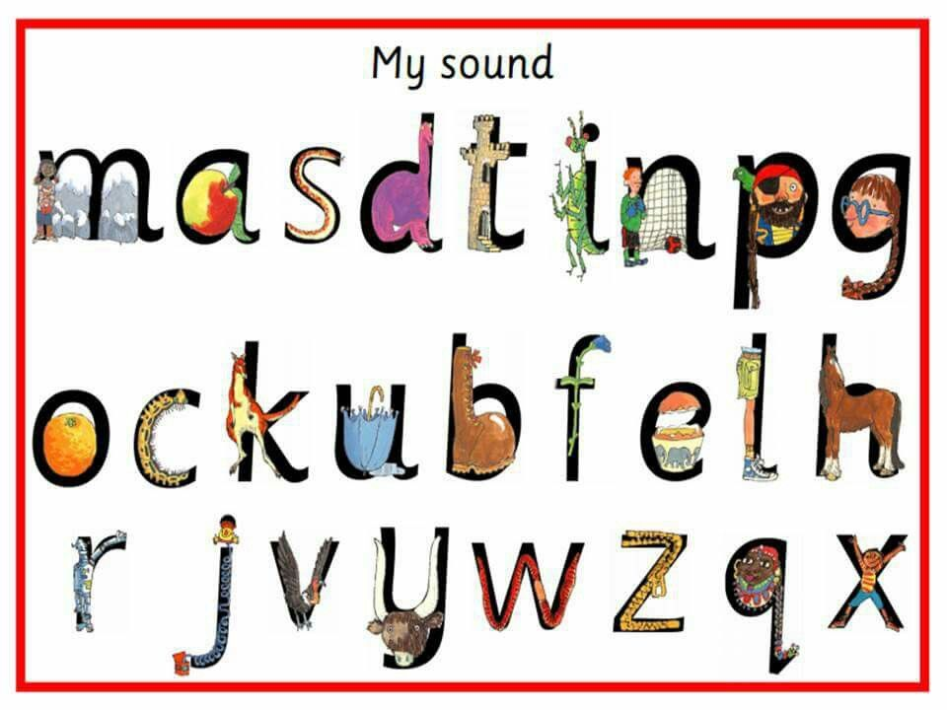
Monday: RWI sound mat: Read all the sounds you know.
Tuesday: Practise initial sounds: (First 5 sounds)
i | n | p | g | o

i – Down the insects body and give him a head.
n – Down Nobby and over his net.
p – Round the pirates face and down his plait.
g – Round the girls face and down her plait.
o – All around the orange.
Wednesday: Simple CVC words for you to sound out/blend.
n | i | p
p | i | n
p | i | g
Thursday: Finding items beginning with i, n, p, g, o …

Can you find items beginning with the first 5 sounds:
i n p g o

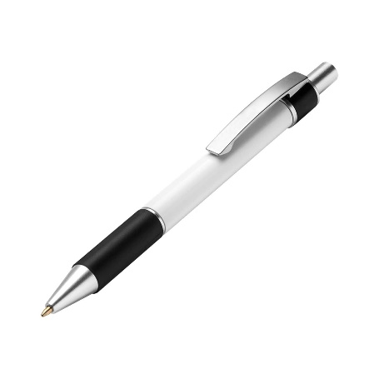

Friday: Practise reading these words without the dots and dashes. Point to each sound and then try to blend the sounds to read the word correctly.
in | pin | pig
pad | man | sad

