[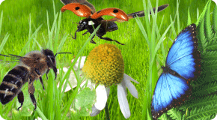](https://www.google.co.uk/url?sa=i&url=http%3A%2F%2Fwww.jcbexplore.com%2Fcontent%2Factivities%2Fkids_zone%2Findex.aspx%3Fid%3DNext&psig=AOvVaw0XSldj5ybyPyEFc1uwKpSU&ust=1585230475165000&source=images&cd=vfe&ved=0CAIQjRxqFwoTCMihsvLhtegCFQAAAAAdAAAAABAD)

Pack 5 - Minibeasts

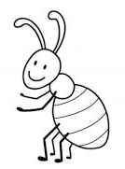[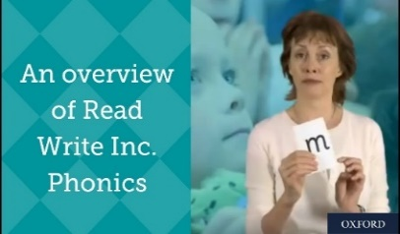](https://www.google.com/url?sa=i&url=https%3A%2F%2Fwww.youtube.com%2Fwatch%3Fv%3D-6dSsXkD1wM&psig=AOvVaw0fINrufF0P__InrUwFcPkP&ust=1585145231441000&source=images&cd=vfe&ved=0CAIQjRxqFwoTCNCpuqaks-gCFQAAAAAdAAAAABAE)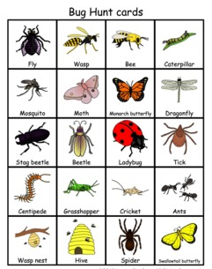[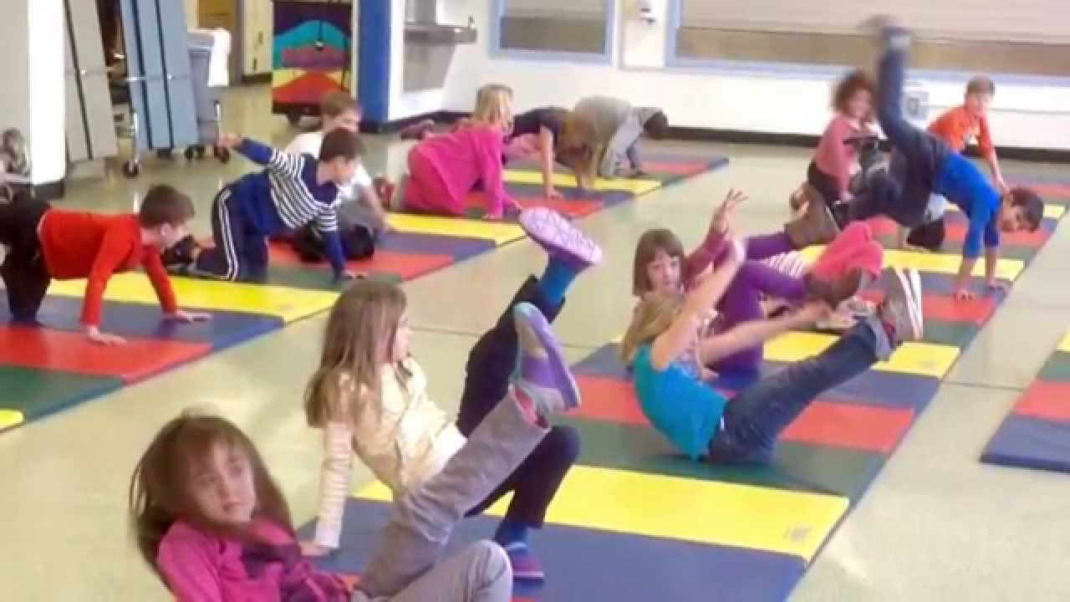](https://www.google.co.uk/url?sa=i&url=https%3A%2F%2Fwww.youtube.com%2Fwatch%3Fv%3DkKmwtddbmFY&psig=AOvVaw1CO0U6DeUlmgsSRgfVlCGI&ust=1585670022929000&source=images&cd=vfe&ved=0CAIQjRxqFwoTCIj86KjHwugCFQAAAAAdAAAAABAD)[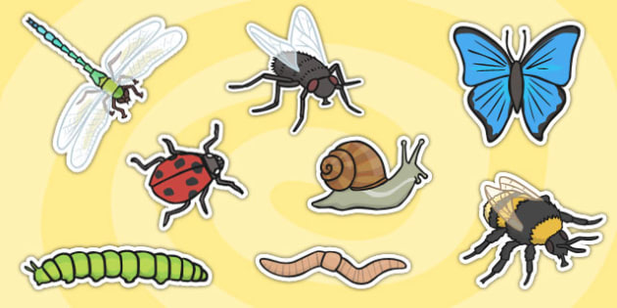](https://www.google.co.uk/url?sa=i&url=https%3A%2F%2Fwww.twinkl.co.uk%2Fresource%2Ft-t-7766-detailed-minibeast-a4-cut-outs&psig=AOvVaw3GAUhL8yNPddgXY9mrJKye&ust=1585307971763000&source=images&cd=vfe&ved=0CAIQjRxqFwoTCOD4z8qCuOgCFQAAAAAdAAAAABAN)[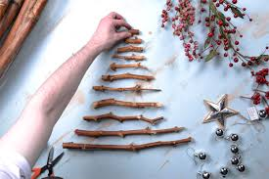](https://www.google.co.uk/url?sa=i&url=https%3A%2F%2Fwww.countrybaskets.co.uk%2Finspiration%2Fhanging-stick-christmas-tree%2F&psig=AOvVaw1bPcoyi-_xRsSNS8OUllV1&ust=1585308581199000&source=images&cd=vfe&ved=0CAIQjRxqFwoTCPCXu-yEuOgCFQAAAAAdAAAAABAD)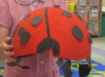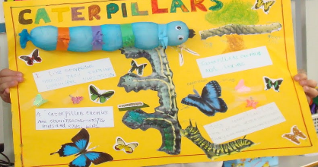

**Phonics - Read Write Inc**

Just in case you are not aware, this is the Ruth Miskin RWI videos which your child can watch to help with their learning of phonics.

Set 2 Speed Sounds at 10.00 am

<https://www.youtube.com/watch?v=n9bAzZa_AeE>

**P.E-** Can you crawl like a ladybird, wriggle along the floor like a worm, slither slowly like a snail, fly around fast like a buzzing bee, fly as quietly as you can like a butterfly?

***Writing –*** Can you find facts about Minibeasts and copy them onto some paper?

Watch this YouTube clip about facts on bees:

<https://m.youtube.com/watch?v=ta154f5Rp5Y>

**Maths -** Can you find sticks in your garden or on a walk and compare the lengths? Use the words; long, longer, longest, short, shorter, shortest. For example, “this stick is shorter than this stick.”

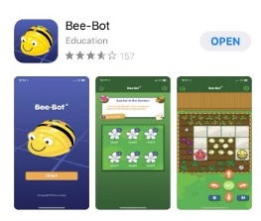

ICT – This is an app you can download and can control the Beebot by giving him instructions.

***Understanding the World –*** Can you go on a bug hunt around your garden or around the local area on your daily walk and tell an adult what they are?

***Art –*** Can you draw and colour in this picture in the lines using various colours?

**SILVER**