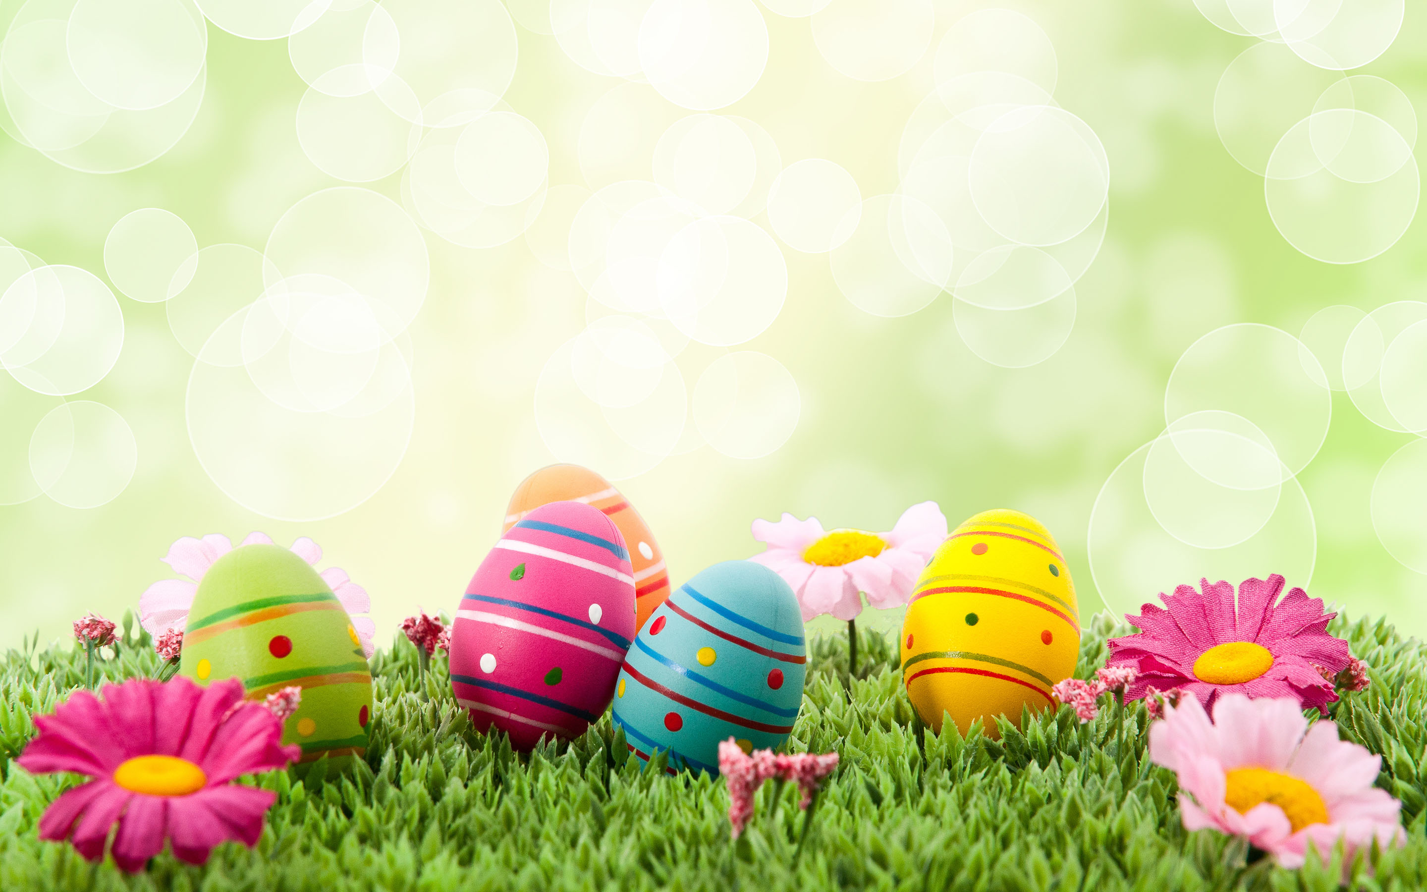

Red Challenge:

Perform an Easter song? For example:

Chick, chick, chicken.

Peter Rabbit has a fly upon his nose.

See the bunnies sleeping.

Orange Challenge:

Can you build a house for the Easter Bunny? You could use fabric, boxes, Lego, plastic tubs etc. Can you combine different materials?

Yellow Challenge:

Can you make an Easter card for someone in your family? You could include a picture of an Easter egg and include a repeating pattern!

Green Challenge:

Can you have a ‘bunny hopping’ race with your family? What other animals could you pretend to be and race as?

Purple Challenge:

Can you share your Peter Rabbit Imagination Library book?

Can you name any characters? Can you talk about what happened in the story?

Blue Challenge:

Can you draw a bouquet of flowers?

You could use crayons, chalk or paint? What colours will you choose? Can you mix colours together to make another colour?

Other ideas:

* Can you grow a carrot top? See instructions below!
* Can you make some Easter crispy cakes?
* Can you move like a chick or a chicken?
* Can you go on a nature hunt in your garden? What can you find? Flowers, blossom, bees, butterflies?
* Can you have an egg and spoon race?
* What can you make? Bunny mask? Toilet roll chick?

Don’t forget to continue:

* to practise your phonics
* to practise reading key words
* to practise reading numbers
* to practise counting, anything!



**Rainbow Challenges: you may want to colour a part of the rainbow when you complete a challenge. Or draw your own rainbow to colour!**

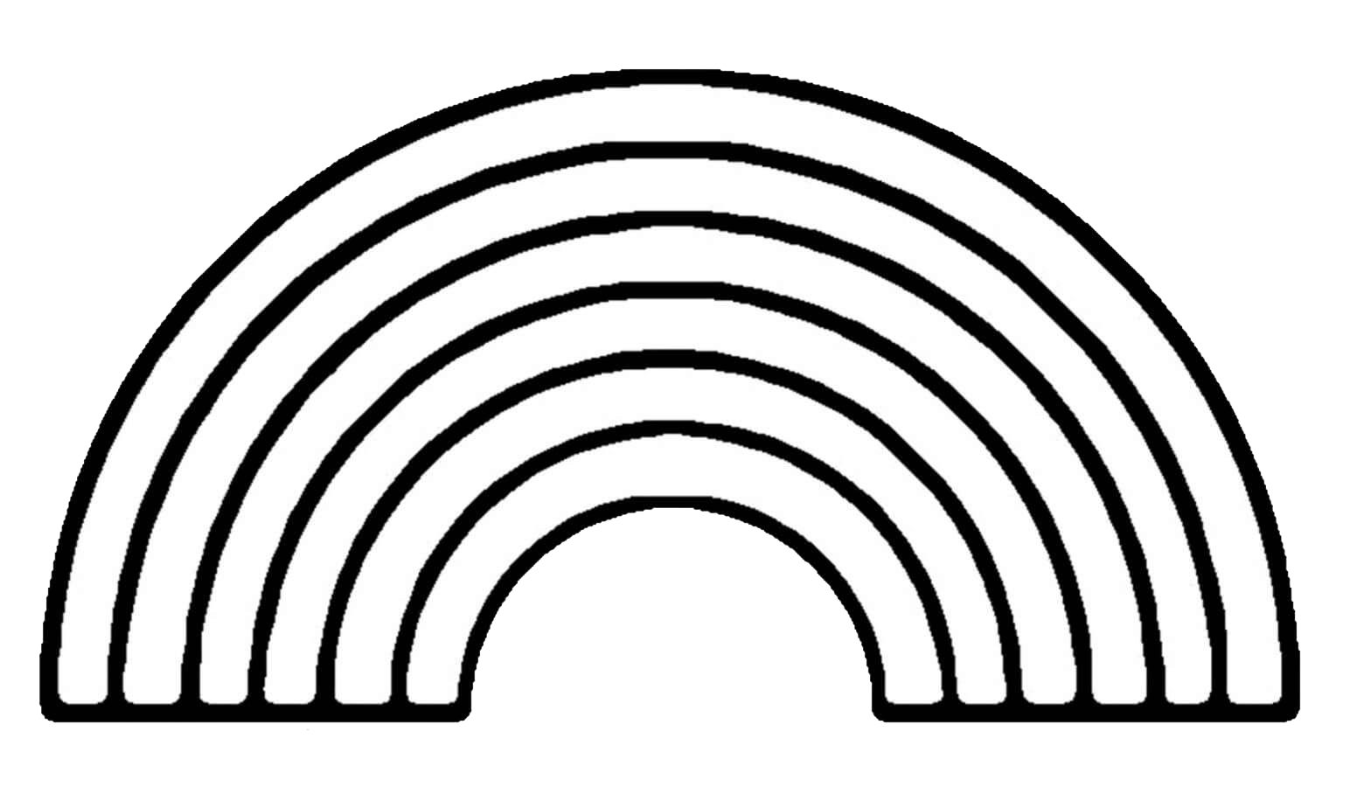

**GOLD**

**F2 Home Learning - Easter**

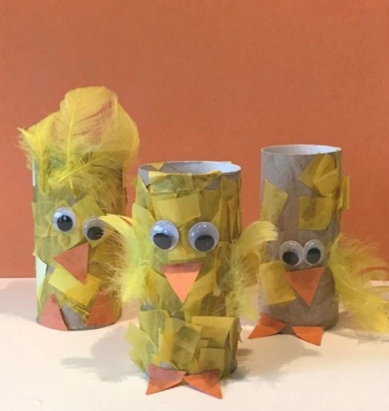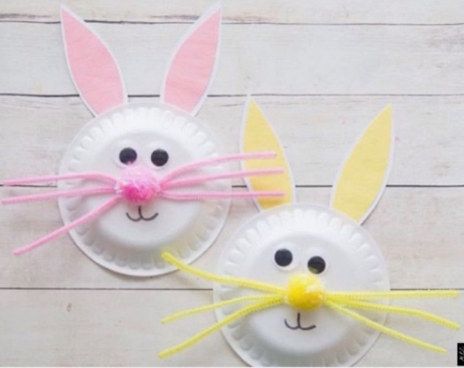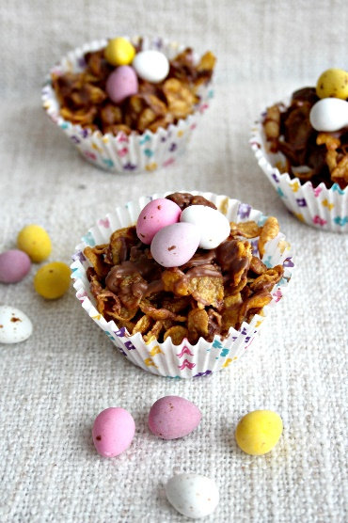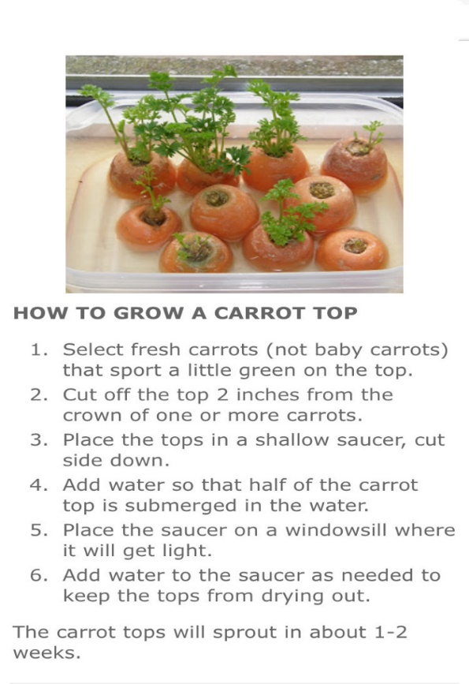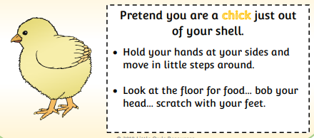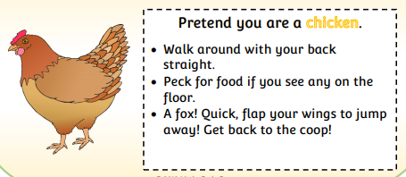

**Sleeping Bunnies**

See the little bunnies sleeping til it’s nearly noon  
Shall we wake them with a merry tune?  
They're so still, are they ill?  
No! Wake up bunnies!  
Hop little bunnies, hop, hop, hop  
Hop little bunnies, hop, hop, hop  
Hop little bunnies, hop, hop, hop  
Hop little bunnies, hop and stop

**Chick, Chick, Chicken**

Chick, chick, chick, chick, chicken,  
Lay a little egg for me!  
Chick, chick, chick, chick, chicken,  
I want one for my tea,  
I haven’t had an egg since Easter,  
And now it’s half past three,  
So, chick, chick, chick, chick, chicken,  
Lay a little egg for me!

**Little Peter Rabbit**

Little Peter Rabbit had a fly upon his nose,  
Little Peter Rabbit had a fly upon his nose.  
Little Peter Rabbit had a fly upon his nose,  
So he flipped it and he flopped it  
And the fly flew away.

Floppy ears and curly whiskers,  
Floppy ears and curly whiskers,  
Floppy ears and curly whiskers,  
So he flipped it and he flopped it  
And the fly flew away.