

10 minutes

Talk about the days of the week and the weather.

Monday, Tuesday, Wednesday , Thursday,

Friday, Saturday and Sunday too.

1 2 3 4 5 6 7 days.

Each day different and everyday new.

Here are some fun activities to share every day at home with your child.

Oasis Academy Henderson Avenue

Foundation 1 Pack 2

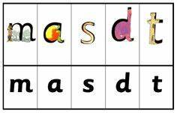

10 minutes

Talk about the sound ‘m , a, s, d, t ‘

Practise writing your name and sounds, draw a picture to go with each sound.

 10 minutes

Talk about the different colours you can see.

Make a rainbow to put in your window to make people smile….

10 minutes

Count together **1 ,2,3,4,5,6,7,8,9,10**

Use the number line to talk about the numbers.

|  |  |  |  |  |  |  |  |  |  |
| --- | --- | --- | --- | --- | --- | --- | --- | --- | --- |
| **1** | **2** | **3** | **4** | **5** | **6** | **7** | **8** | **9** | **10** |

Count objects…fingers, shoes, socks, pencils...



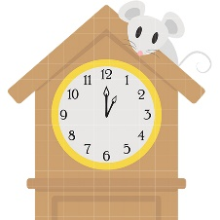

Have fun talking and playing together.

Foundation 1 Team.

10 minutes

Share Rhymes and stories together.

10 minutes

Talk about shapes you can find around the house and in the garden.