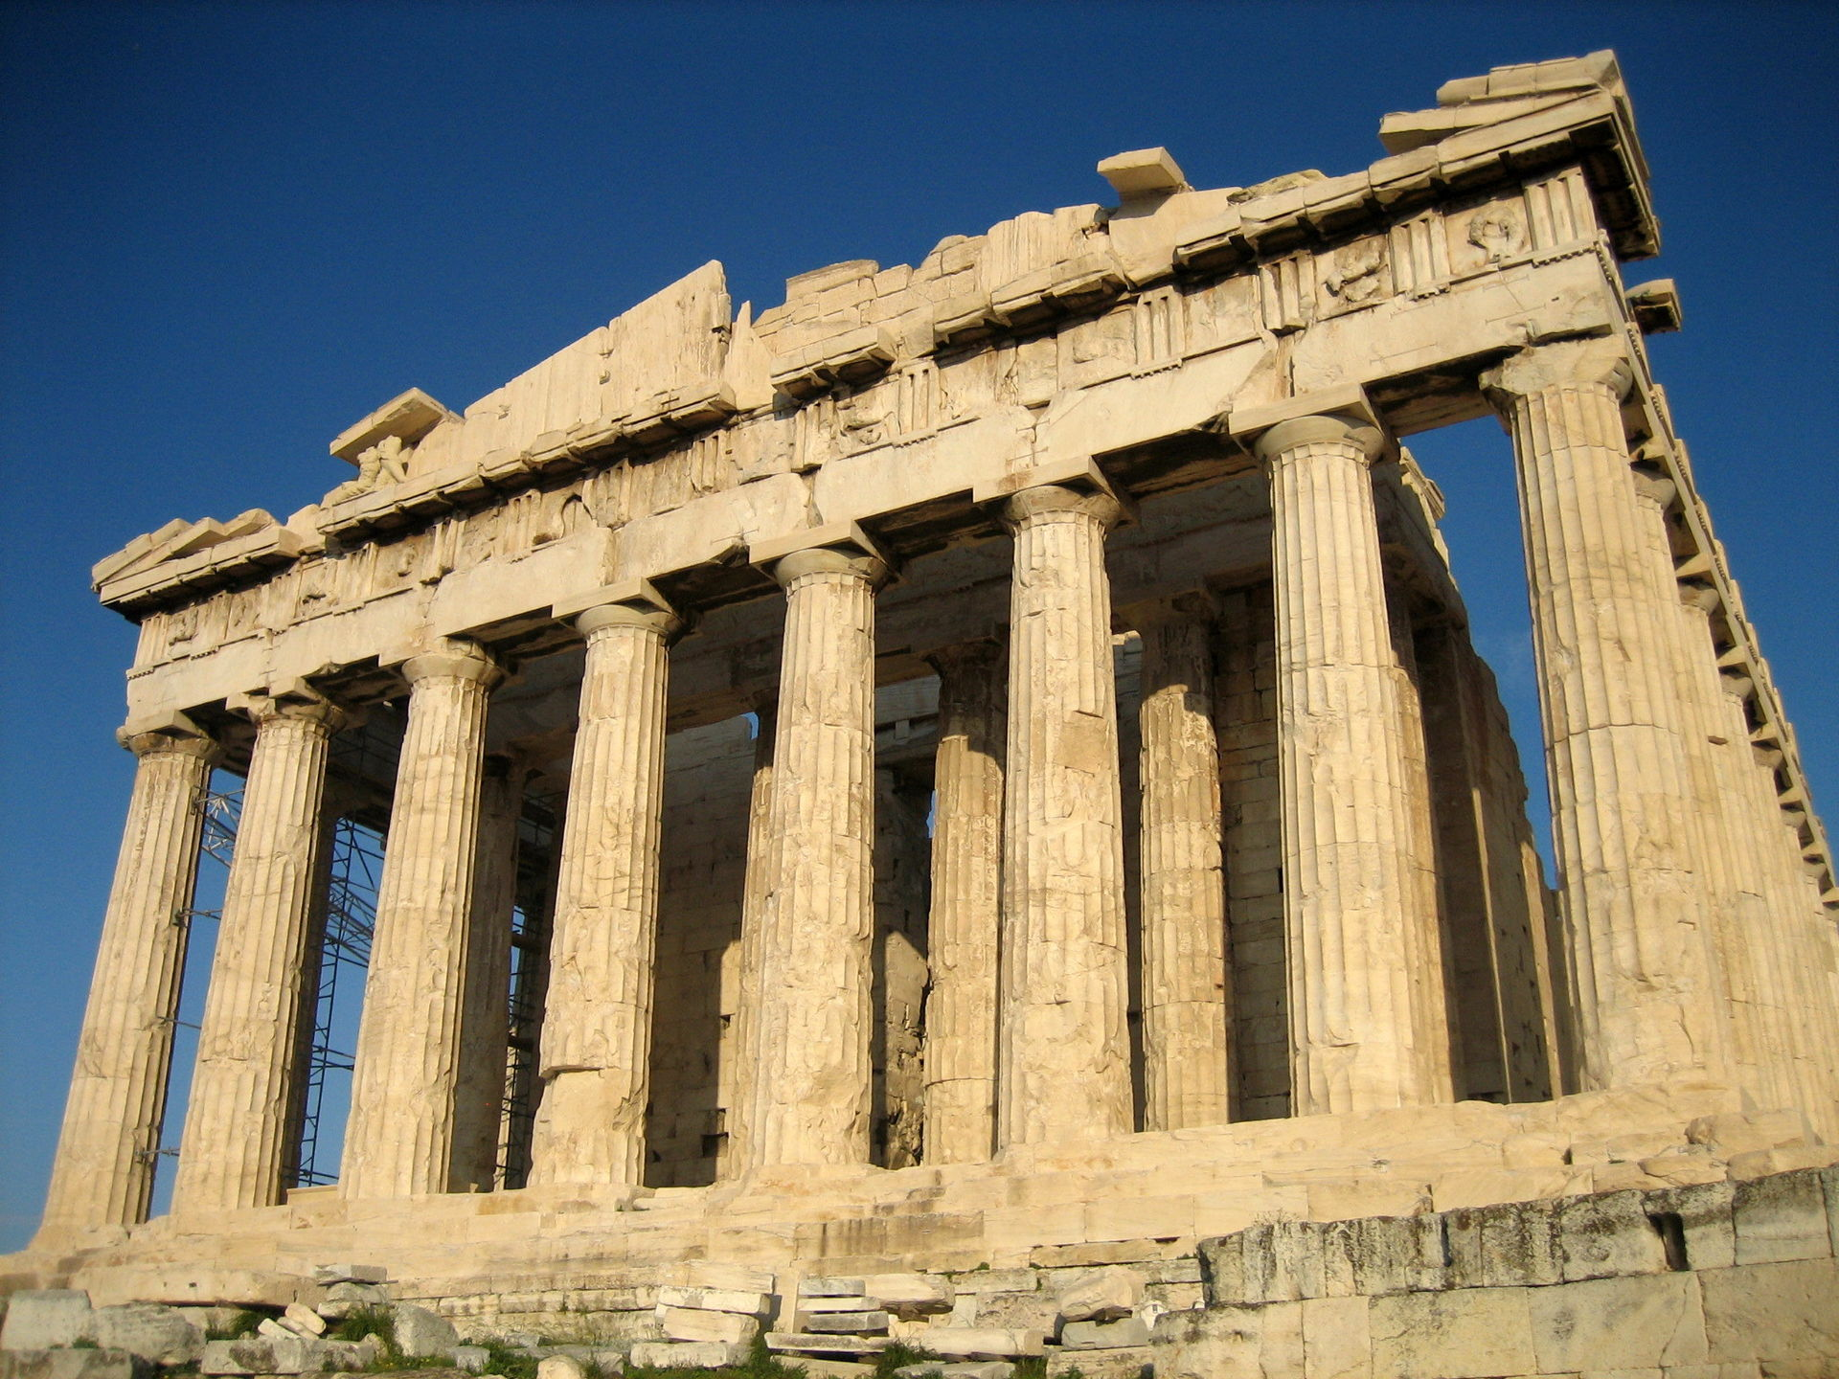
Ancient Greece Project - Week 2

Geography
- To locate places that were significant in Ancient Greece and add to the map.
- To create a fact file on Greece.
Art and design.
- Research Ancient Greek clothing and sketch a chiton.
- Take inspiration from what you have learnt at school and design a pot with a different purpose.
P.E
- Think about what you have learnt in lessons and create a poster showing everything you know about the Olympics.
- Hold a mini Olympics in your own home!
History
- To investigate and understand democracy and compare it to the present day in the UK.
- Research Aristotle and find out why he was so important.
Maths
- Complete the Ancient Greek word problems.
- Complete the arithmetic questions
Literacy & Reading
- Read/listen to the Greek Myth ‘King Midas and the Golden touch.’ https://www.bbc.co.uk/teach/school-radio/ks2-primary-history-ancient-greece-king-midas-and-the-golden-touch/z4wyhbk
- Answer the retrieval questions and draw images to show the sequence of events.
- Summarise the story in 5 key bullet points.

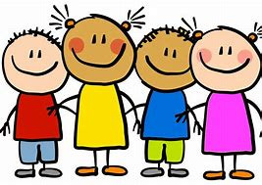
Dear children, parents and carers,

Although school is closed, we still want you to have access to high-quality
resources. To help you and to provide online access to these resources, please take a look at the links below. They are all FREE!
Also please follow these your teacher on twitter for regular updates!
- @MarshallOAHA
- @GladmanMiss
- @MissWilliamsY5
Keep working hard and stay safe!

ukhosted14.renlearn.co.uk/6698989 - This is the website which children in years 3 to 6 use to quiz on books they have read. Children will now be able to access this from home, Monday to Friday.
https://ttrockstars.com/ - This is a website where children are able to practise their times tables.
Lovereading4kids.co.uk - An extensive library of books, including classics and brand new released, with reviews, plots and downloadable extracts. Sign up for free.
https://pages.sumdog.com/ This is a website where children can complete maths and spelling practise.
https://www.bbc.co.uk/bitesize/levels/zbr9wmn A website where children and parents can access all curriculum areas.
Twinkl.co.uk/offer A website where children and parents can access all curriculum areas. To access enter the code UKTWINKLHELPS
https://www.duolingo.com A website where children can learn a new language. At OAHA we teach French.
https://classroomsecrets.co.uk/ A website where children can access all curriculum areas.
https://shop.scholastic.co.uk/homelearning A pack of work for home learning.
https://whiterosemaths.com/ A website full of maths resources.
https://2simple.com/free-access/ A website full of cross-curricular activities and resources.
Pobble365.com A website with writing ideas and photo stimuli.
https://www.spellingshed.com/en-gb Sign up for free!
https://www.mathshed.com/en-gb Sign up for free!

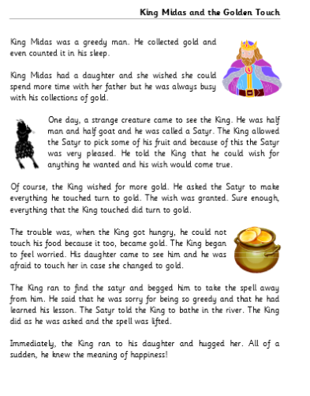
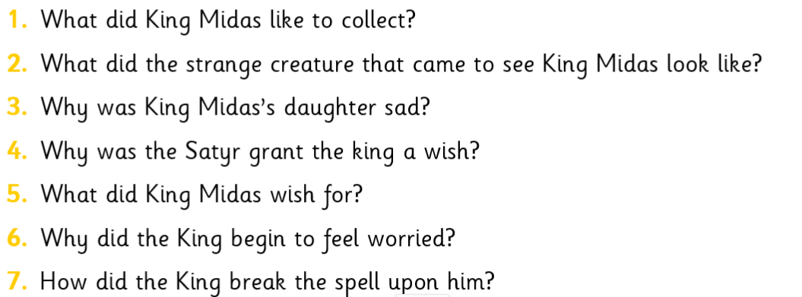
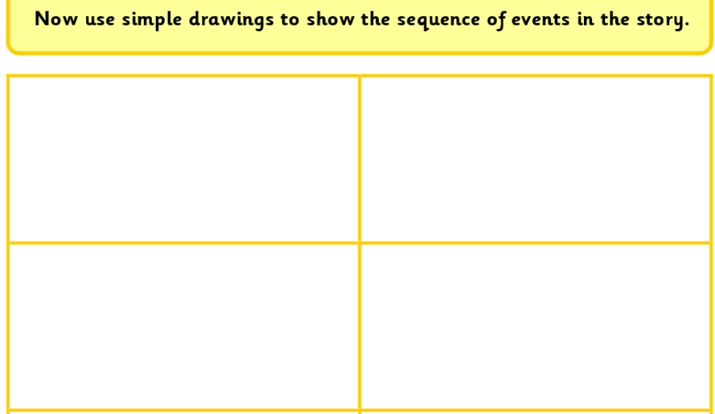
LITERACY
MATHS
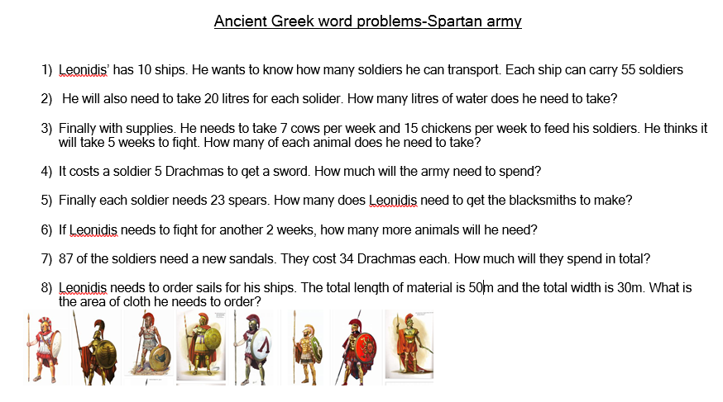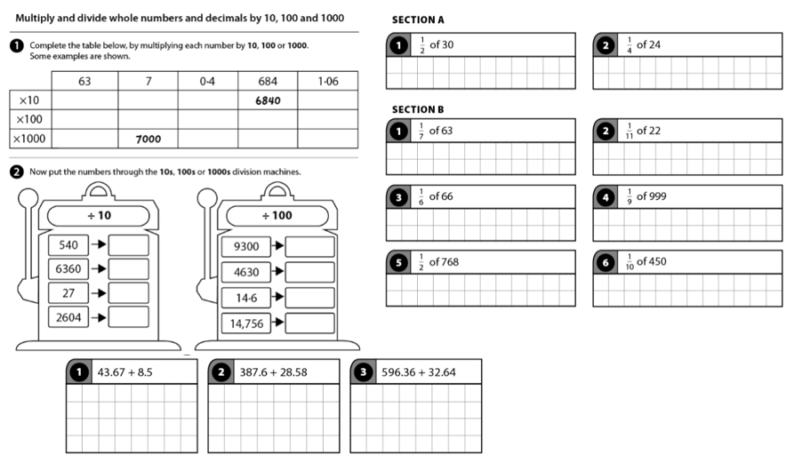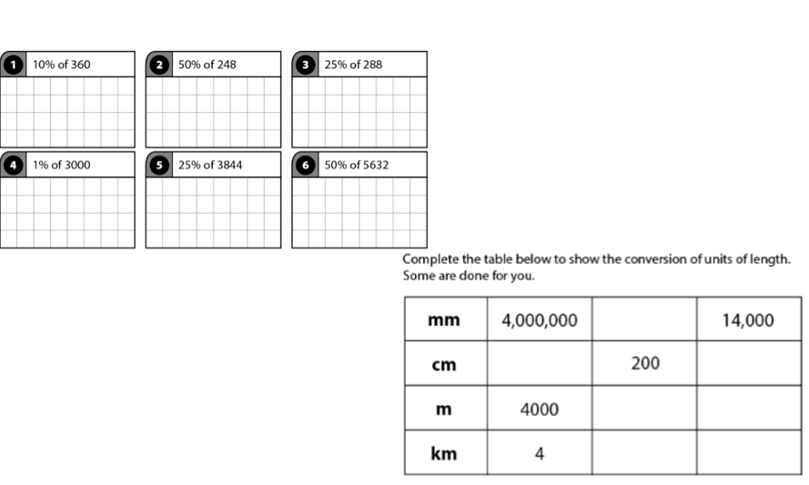

Art and Design
Create a project with inspiration your BrainBuilder which is related to the Ancient Greeks. Get as creative as you can! Use whatever materials you have available and use your imagination! Here are some images you can take inspiration from.
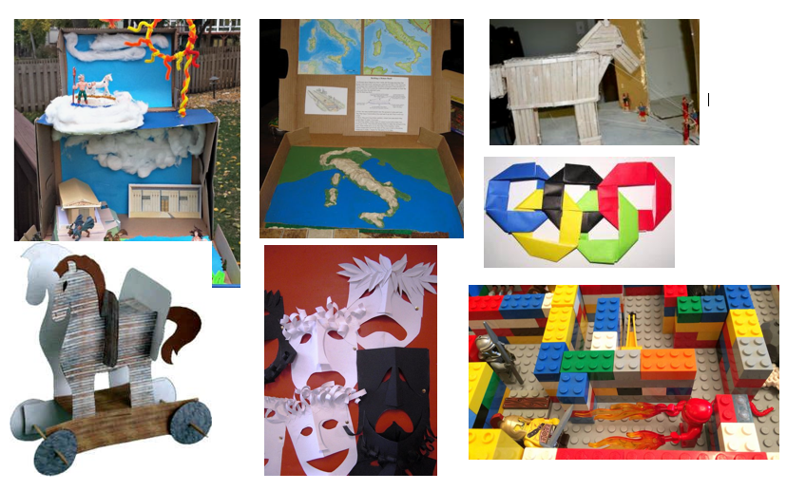

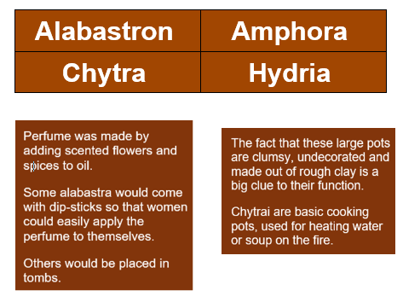
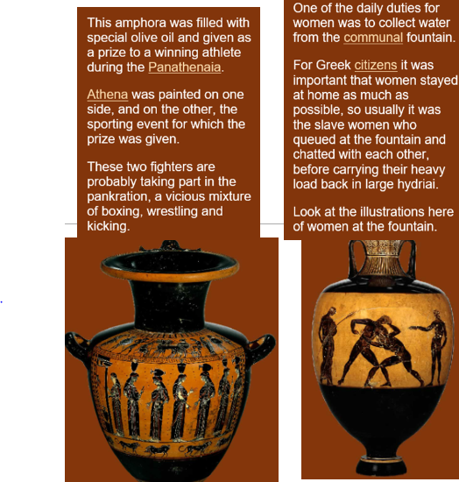
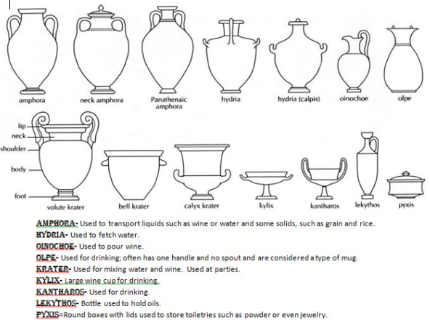

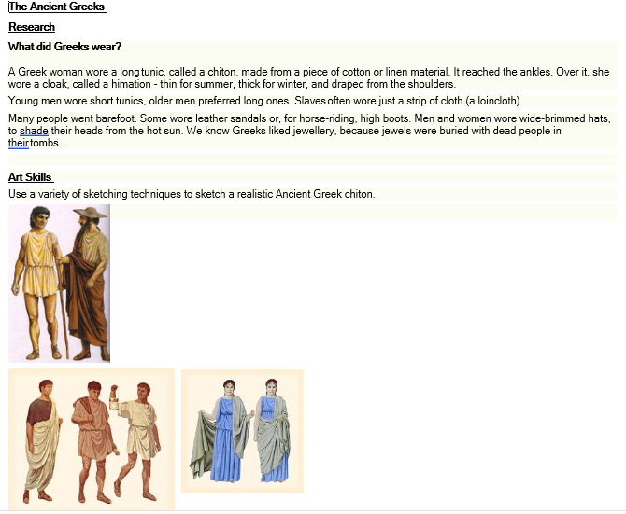

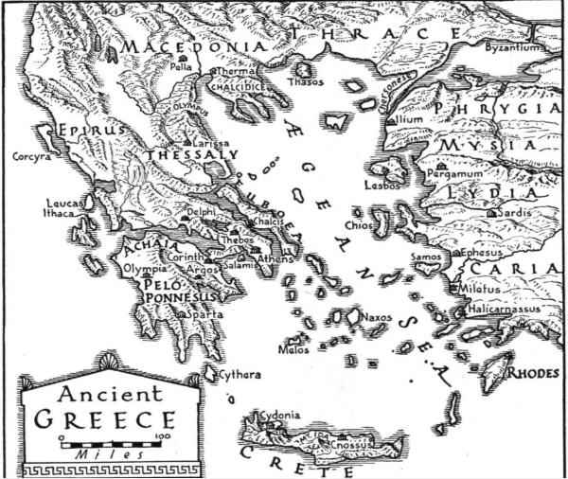
GEOGRAPHY

Illium  Another name for this city was Troy. It was on the eastern shores of the Aegean Sea in the area known as Phrygia. A famous battle took place here which was ended by a wooden horse! | Sparta  This is found on the peninsula to the south of Greece. It was little more than a group of villages built around a central hill. It became the chief Greek city for short time after it won a war against Athens. The Spartan army was the bravest of all Greek armies
Mount Olympus  This mountain is still the tallest on mainland Greece at 2,917 metres. The Greeks believed it was the home of their gods and goddesses.  It is situated north of Thessaly | Macedonia  This is in the far north. Its name came from a word meaning ‘highlanders’. It was the home of the powerful Philip II and his son Alexander the Great
Delphi  This place can be found on the Greek mainland just north of Peloponnesus.  The Ancient Greeks believed this was the very centre of the world. They built one of their most important shrines here. | Marathon  This place was where a famous battle took place between a small Greek army and a much larger army from Persia. The Greek army was victorious, saving Athens from being attacked.  Marathon is a short distance north west of Athens, just where the coast bends and goes directly north.
Athens  If you cross the strip of land from Peloponnesus towards the mainland and head east you will arrive at the city of Athens.It was named after Athena, goddess of wisdom and became the most important city in Greece. The idea of democracy - ‘ power by the people’ - began here. The famous Parthenon Temple was built on a hill above the city | Olympia  Olympia is situated on the peninsula of Pelonneseus. It was the giant sports complex where the Olympic Games festival was held. This was the most important Greek festival and took place every four years in honour of Zeus. The statue of Zeus at Olympia was one of the Seven Wonders of the Ancient World
Corinth  The city state of Corinth had 900 square kilometres of mountains and farms. It was situated between the two other city states of Sparta and Athens. From the name ‘Corinth’ we get the English word ‘currant’ - for small blck grapes which have been dried in the sun.Unlike Athens, Corinth was ruled by an ‘Oligarchy’ which means ‘government by a group of people’. | Peloponnesus  This jagged shaped peninsula in the south is also referred to as Peloponnese. It is joined to the rest of the mainland by a strip of land only 11 kilometres wide. Its name means ‘Island of Pelops’ Pelops was a prince in a Greek story.  Ancient Greek civilisation began in this part of Greece and the entrance to Hades is believed to be on its northernmost coast
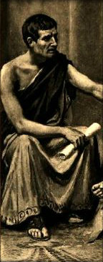
HISTORY
Aristotle
- Aristotle was a scientist and philosopher who was born in Greece in 384 BC. Today he is considered one of the best known and most important of all philosophers.
- He was born into a noble and wealthy family. His father was the personal doctor to King Amyntas who helped to bring peace to the Macedonian area.
- Aristotle spent much of his life in Athens, then the world’s largest city.
- He studied biology, politics, physics, music, languages, poetry and ethics at the school of another well-known philosopher, Plato.
- He invented a new science called causality, which explained why events happen. He also devised a new way of looking at situations and events by looking for clues as to what happened.
- Aristotle designed a primitive camera, in which the sun shone into a dark box, creating an image. He also made studies of the stars and planets, and wrote books about physics and geology.
- Aristotle classified animals into different types, and studied the marine life in the nearby ocean. He believed that living things were created on a scale, ranging from plants to humans.
- He made notes to help his students, and also wrote many books and papers. However, only about 30 percent of what he wrote survives today, and many of his works were also edited over the years.
- Aristotle was the first known person to say that the continent of Antarctica existed. The Aristotle Mountains, along the north coast of Antarctica are named for him.
- Towards the end of his life he tutored Alexander the Great, as well as two other future kings. He founded his own school, called the Lyceum.
- He died in 322 BC, aged 62 and has been called the most intelligent man who ever lived. His method of questioning things and many of his ideas have influenced philosophers for many centuries.

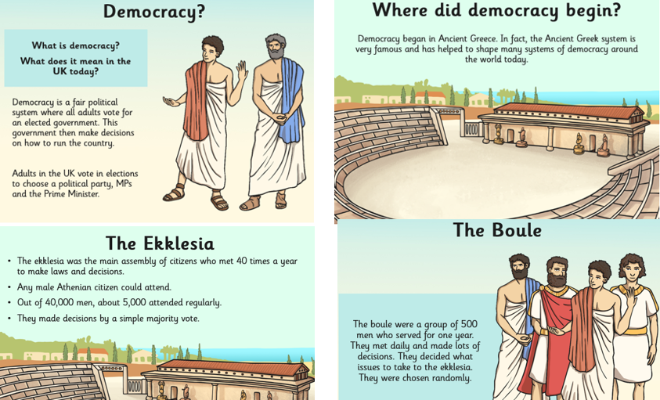

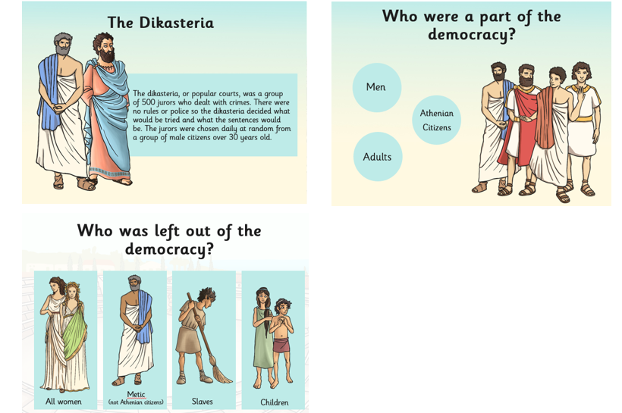
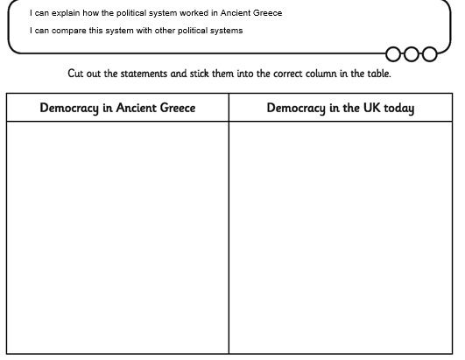

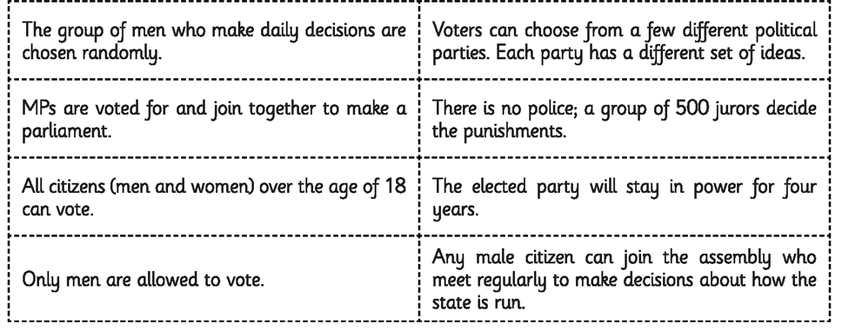
Cut up these statements and put them in the correct column in the grid above

PE

